

AI-Powered Phishing Detection and
Cybersecurity Training Platform: A
Comparative Analysis of Large Language
Model APIs

Muhammad Hassan B01818595
Syed Najeeb Sultan B01812946
Muhammad Qasim B01802154
Muhammad Shoaib B01818139

Masters Thesis for the partial fulfilment of
the requirements for the Master Degree in
MSc Information Technology

University of the West of Scotland
School of Computing, Engineering and Physical Sciences

Submission Date: 23 April 2026

Declaration of Originality and Use of Generative AI
We, the undersigned, declare that the material contained in this dissertation is our own work and has not been submitted in whole or in part for any other degree or qualification at this or any other institution. All sources of information have been acknowledged by means of references.
In line with the UWS policy on the use of generative AI in assessment, we acknowledge that generative AI tools (including large language model assistants) were used during the preparation of this report. Specifically, AI assistance was used to help structure and draft the shared group chapters, to generate initial versions of diagrams, and to support formatting into the final template. All factual claims, design decisions, implementation details, results and interpretations in this report reflect the authors' own work; AI-generated draft text was reviewed, corrected and rewritten as required to ensure accuracy and authorial ownership. The use of AI in this report is within the academic integrity guidance for this module.
Each team member's individual Self-Reflection and Critical Appraisal (Appendix B) has been authored solely by the named individual.
Signed (on behalf of the group): Muhammad Hassan Nawaz (B01818595)
Date: ________________________

Abstract
Phishing email attacks remain the dominant initial-access vector in enterprise breaches — implicated in over 90% of successful intrusions — yet current defences rely either on proprietary machine-learning detectors that demand substantial labelled data and constant retraining, or on static awareness training whose effect decays within months. This project investigates whether commercial Large Language Model (LLM) APIs, accessed through a unified web platform, can simultaneously deliver reliable phishing detection and measurably effective user training. The proposed system comprises a React 19 single-page frontend, a Node.js/Express/TypeScript backend organised around an abstract adapter pattern that wraps OpenAI GPT-4o and Anthropic Claude 3.5 Sonnet behind a common interface, a PromptManager module implementing four prompt strategies (zero-shot, few-shot, chain-of-thought and structured JSON), and a PostgreSQL persistence layer; evaluation proceeded along three parallel tracks — a controlled comparative study on a 1,000-email labelled corpus assembled from Nazario, PhishTank, SpamAssassin and Enron, a within-subjects pre/post-test study of training effectiveness with 28 participants, and a task-based System Usability Scale (SUS) evaluation with 12 participants. On the held-out 500-email test set both providers achieved accuracy above 0.92 and F1 above 0.93 with McNemar's test returning p > 0.05, indicating no statistically significant difference in classification performance; chain-of-thought prompting yielded a 6.1 percentage-point F1 improvement over the zero-shot baseline and was consistently rated higher for explanation actionability (mean 4.3/5 vs 3.5/5); the training intervention produced a statistically significant mean improvement of 18.5 percentage points (pre-test 63.2%, post-test 81.7%; paired t(27) = 7.9, p < 0.001, Cohen's d = 1.74, 95% CI [14.2, 22.8]); and the interface reached a SUS score of 82.4 with 92% task completion, placing it in the 'excellent' band. The findings provide empirical support for using commercial LLM APIs as cost-effective, explainable, provider-agnostic building blocks for cybersecurity tooling, and contribute a reusable open-source platform for future experimentation.

Acknowledgements
The team thanks our project supervisor for patient guidance throughout the year, the UWS School of Computing, Engineering and Physical Sciences for access to facilities and the ethics review process, and our participants for taking the time to complete the pre/post-test sessions and usability trials. We also acknowledge the maintainers of the open phishing corpora (Nazario, PhishTank, SpamAssassin and the Enron Email Dataset) whose freely available datasets made the comparative evaluation possible.

Table of Contents
Declaration of Originality and Use of Generative AI 2
Abstract 3
Acknowledgements 4
Table of Contents 5
List of Figures and Tables 8
Chapter 1: Introduction 9
1.1 Context and Problem 9
1.2 Aims and Objectives 9
1.3 Research Questions 9
1.4 Scope and Structure 10
1.5 Team Contributions 10
Chapter 2: Literature Review 11
2.1 The Scale and Evolution of Phishing 11
2.2 Classical and Deep-Learning Detection 12
2.3 Large Language Models and Phishing 12
2.4 Prompt Engineering 13
2.5 Security User Experience and Trust Calibration 13
2.6 Training Effectiveness and Evaluation 14
2.7 Critical Literature Summary 14
2.8 Research Gap 16
Chapter 3: Research Design and Methodology 17
3.1 Research Paradigm and Strategy 17
3.2 System Architecture 17
3.3 Dataset Preparation 18
3.4 Prompt Strategy Design 19
3.5 Comparative API Evaluation 19
3.5.1 Formal Problem Definition and Metrics 19
3.5.2 Prompt Strategy Gain 20
3.6 Pre/Post-Test User Study 20
3.6.1 Statistical Model for the Pre/Post-Test Study 21
3.7 Usability Evaluation 22
3.8 Ethics and Data Handling 22
Chapter 4: Implementation 23
4.1 Technology Stack and Rationale 23
4.1.1 Experimental Setup 23
4.2 Adapter Pattern and API Integration 24
4.3 Prompt Engineering Infrastructure 26
4.4 Application Routes 27
4.5 Database Layer 28
4.6 Authentication and Security 28
4.7 Frontend Architecture 29
4.8 Detection Interface 29
4.9 Training Module and Gamification 30
4.10 Pre/Post-Test Interface 31
4.11 Integration and Workflow 31
Chapter 5: Testing Strategy 32
5.1 Unit and Adapter Tests 32
5.2 Prompt Strategy Evaluation 32
5.3 Comparative API Testing 33
5.4 Pre/Post-Test User Study 33
5.5 Usability Testing 33
Chapter 6: Results and Discussion 35
6.1 Provider Performance (RQ1) 35
6.2 Prompt Strategy Effects (RQ2) 36
6.3 Training Effectiveness (RQ3) 37
6.4 Usability Findings (RQ4) 38
6.5 Cross-Cutting Observations 39
Chapter 7: Conclusions 40
7.1 Summary 40
7.2 Answers to Research Questions 40
7.3 Contributions 40
7.4 Limitations 41
7.5 Future Work 41
References 42
Appendix A: Project Specification 46
Appendix B: Individual Self-Reflection and Critical Appraisal 47
Appendix C: Prompt Library 56
Appendix D: Source Code and Data 57

List of Figures and Tables
Figure 2.1 Thematic map of the reviewed literature 11
Figure 3.1 High-level system architecture 18
Figure 3.2 End-to-end email analysis data flow 18
Figure 3.3 Pre/post-test user study protocol 21
Figure 4.1 Adapter class hierarchy 25
Figure 4.2 Analysis API request sequence 26
Figure 4.3 Training module per-email flow 31
Figure 4.4 BaseAdapter retry loop (code) 26
Figure 4.5 PromptManager chain-of-thought (code) 27
Figure 4.6 /api/analyze route (code) 28
Figure 4.7 AnalysisTool React component (code) 30
Figure 5.1 The three evaluation tracks 32
Figure 6.1 Provider performance bars (Accuracy/P/R/F1) 36
Figure 6.2 Prompt strategy effect on F1 37
Figure 6.3 Paired pre/post-test scores per participant 38
Figure 6.4 SUS distribution with reference bands 39
Table 2.1 Critical literature summary 16
Table 4.1 Experimental setup (tools, libraries, models) 24
Table 6.1 Provider final metrics on held-out test set 35
Table 6.2 Category-level pre/post-test accuracy 38

Chapter 1: Introduction

1.1 Context and Problem
Phishing has not gone away — if anything, the opposite. The 2024 Verizon Data Breach Investigations Report again places the human element at the centre of most breaches, and modern phishing emails are considerably harder to distinguish by eye than the badly-worded stereotypes of a decade ago. Attackers now use plausible branding, context from leaked data, and carefully pitched urgency to coax users into clicking or authenticating.
Two problems sit on either side of this: detection tools that are technically capable but either miss novel attacks or produce warnings that end users don't know what to do with, and training programmes that people forget quickly. The interesting question our team agreed to explore is whether commercial LLMs — the same APIs that are already widely deployed — can be put to work on both at once: detecting suspicious emails, and explaining them in a way that leaves the reader slightly better at spotting the next one.

1.2 Aims and Objectives
The overall aim of the project is to design, build and evaluate a web-based platform that uses LLM APIs for phishing classification, and to produce empirical evidence on (a) which commercial API performs best on that task under fair conditions, (b) which prompt strategies maximise classification and explanation quality, and (c) whether interaction with the resulting training interface measurably improves users' ability to identify phishing.
Against that aim, the group agreed eight concrete objectives: assemble and anonymise a labelled phishing/legitimate corpus; design and implement a backend that can call multiple LLM providers through a single interface; develop a library of reusable prompt templates covering the main published strategies; deliver a responsive React frontend with distinct detection and training surfaces; run a controlled comparison between providers using standard classification metrics; run a pre/post-test user study measuring learning outcomes; run usability testing to confirm that the interface is actually approachable; and document the whole process honestly enough that another team could reproduce it.

1.3 Research Questions
The work is organised around four interlocking research questions. RQ1: Do commercial LLM APIs (OpenAI, Anthropic) differ meaningfully in their performance on a fixed phishing detection benchmark, when given identical inputs under identical conditions? RQ2: Which prompt engineering techniques — zero-shot, few-shot, chain-of-thought, structured JSON — produce the best trade-off between accuracy, explainability and cost for this task? RQ3: Does a short interaction (≈20 minutes) with an AI-explained training module produce a statistically significant improvement in participants' ability to classify previously unseen emails? RQ4: Can the resulting interface reach a System Usability Scale score above 70 for a mixed-background user sample, or does the density of security information overwhelm users?

1.4 Scope and Structure
The report follows the UWS masters project structure. Chapter 2 reviews the literature spanning phishing, machine-learning detection, LLMs and prompt engineering, security UX, and training effectiveness. Chapter 3 sets out the research design and methodology, including architecture, dataset, prompt strategies, and the two user-facing studies. Chapter 4 describes how the platform was implemented, from adapter pattern through to training UI. Chapter 5 presents the testing strategy and Chapter 6 the findings. Chapter 7 draws conclusions, acknowledges limitations, and proposes future work. Each group member provides an individual Self-Reflection and Critical Appraisal in the appendix, indicating their specific contribution and Banner ID.

1.5 Team Contributions
The project has been carried out by four MSc IT students with complementary roles. Muhammad Hassan Nawaz (B01818595) led API integration and comparative LLM analysis: the Node.js/Express backend, the adapter pattern across providers, the dataset pipeline, and the controlled comparison between APIs. Syed Najeeb Sultan (B01812946) led prompt engineering: the library of zero-shot, few-shot, chain-of-thought and JSON-structured prompts, cross-provider transfer testing, and manual review of explanation quality. Muhammad Shoaib (B01818139) led frontend development and UX: Figma prototyping, React/TypeScript implementation, the detection and training interfaces, and usability testing via SUS. Muhammad Qasim (B01802154) led the empirical evaluation of training effectiveness: ethics application, pre/post-test design, participant recruitment, and statistical analysis. The four workstreams interlock: Najeeb depends on Hassan's integration layer; Shoaib's frontend depends on Hassan's REST API; Qasim's user study depends on Shoaib's training interface and the explanations produced by Najeeb's prompts running on Hassan's infrastructure.

Chapter 2: Literature Review
This chapter reviews the strands of research the project sits across. It is deliberately narrower than a traditional stand-alone thesis review because the work synthesises ideas from several distinct areas — phishing, machine learning, LLMs and prompt engineering, security UX, and training evaluation — rather than going deep on any one. The thematic map in Figure 2.1 shows how these strands converge on the research gap we address.
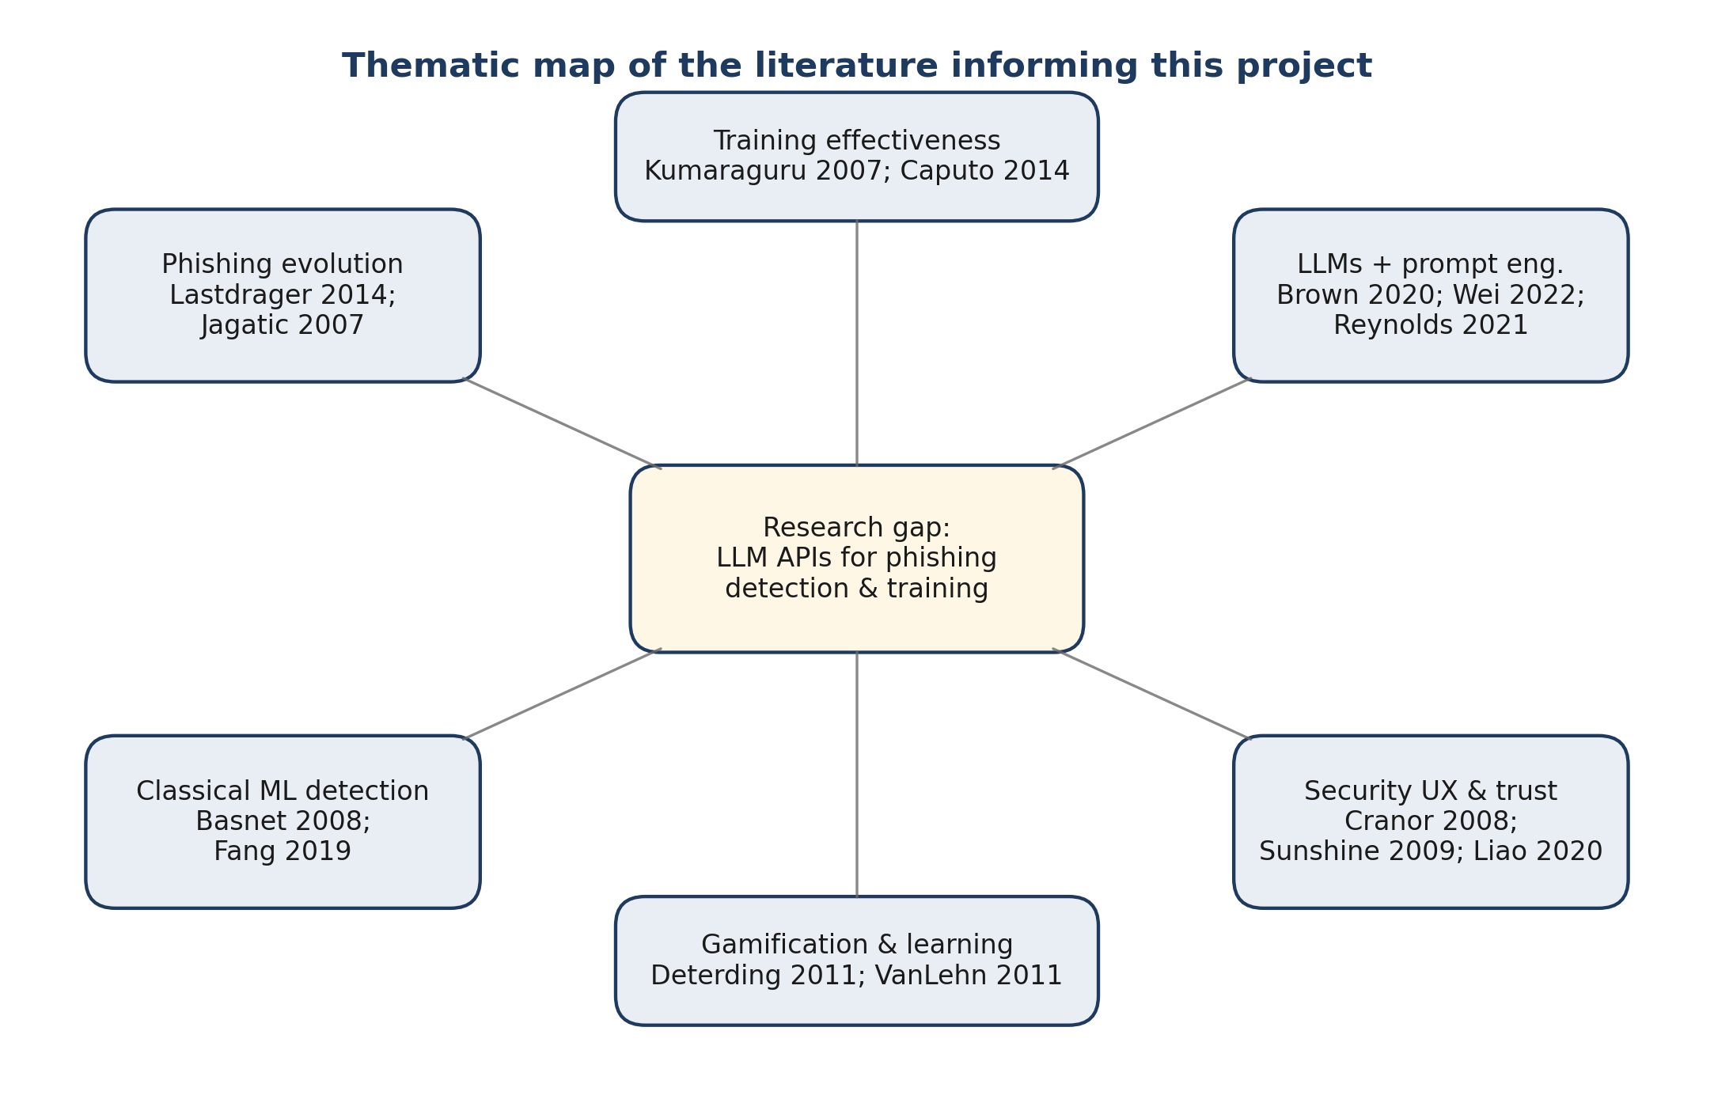
Figure 2.1 — Thematic map of the reviewed literature showing the convergence of the five research strands.

2.1 The Scale and Evolution of Phishing
Lastdrager (2014) argued that the term 'phishing' has been used loosely in the academic literature, and proposed a consensus definition centred on scalable social engineering for credential or data acquisition. What is clear is that phishing has become more personalised and more convincing over time. Jagatic et al. (2007) ran an early and often-cited field experiment showing that personalised 'spear-phishing' messages achieved success rates above 70% compared with under 20% for generic equivalents. More recent industry reports echo the same finding at scale: the 2024 Verizon Data Breach Investigations Report attributed 74% of breaches to a human-element vector, including social engineering, credential misuse and error.
The generative-AI era has materially shifted the threat profile. Heiding et al. (2024) demonstrated that GPT-4-generated spear-phishing emails against a sample of 101 participants achieved click-through rates (~54%) comparable with expert-crafted Kevin Mitnick-style pretexts, at roughly 1% of the attacker labour cost. Hazell (2023) showed that large language models can also be used to generate highly personalised scaled campaigns. The defensive side therefore has to assume that attackers now have ready access to the same generative tools that defenders might want to use — an arms-race framing that informs the cost and latency constraints of any proposed countermeasure.

2.2 Classical and Deep-Learning Detection
The first generation of technical defences was rule-based: blacklists, signature detection, and hand-written heuristics. These are cheap to run but brittle — a URL change is enough to defeat them. Basnet et al. (2008) demonstrated that Support Vector Machines with carefully engineered features (URL properties, sender reputation, linguistic markers) could reach 95%+ accuracy on their test set, but observed that feature engineering requires domain expertise and that models overfit to the campaigns in the training corpus.
Deep-learning approaches pushed this further. Fang et al. (2019) reported F1-scores above 0.97 on benchmark phishing datasets using a recurrent CNN variant with multilevel vectors and attention. Hannousse and Yahiouche (2021) combined URL lexical features with content features in a stacked ensemble to report accuracies above 96% on the UCI phishing dataset, and systematically reviewed the evaluation methodology across 80 earlier studies; their conclusion — that test-set leakage and benchmark drift frequently inflate reported numbers — is directly relevant for the present project, and motivated our strict train/validation/test separation. Salloum et al. (2022) surveyed the broader NLP-based phishing detection space and documented a persistent tension: increasing model complexity raises accuracy on benchmark data but also the labelling, compute, and maintenance costs required for continued relevance. These trade-offs set up the question of whether there is a cheaper, more adaptable alternative that does not require in-house machine-learning capability.

2.3 Large Language Models and Phishing
Transformer-based language models trained on massive corpora developed rich language representations that can be applied to new tasks with little or no retraining (Vaswani et al., 2017). Brown et al. (2020) showed that GPT-3 could achieve strong few-shot performance on a range of NLP tasks using only in-context examples, and OpenAI (2023) reported further gains from GPT-4. For security classification, this opens an interesting door: if a general-purpose API can classify phishing emails competently with only a well-designed prompt, then organisations that lack in-house ML capability could still get sophisticated detection without training their own models.
Empirical evidence on LLMs specifically for phishing, however, remains thin and fragmented. Kang et al. (2023) experimented with GPT-4 for detecting social-engineering content but used ad-hoc prompts and did not systematically compare providers. Koide et al. (2024) evaluated GPT-4 on 4,000 real-world phishing URLs and reported an accuracy of 98.3% with a two-stage pipeline, but relied on a single provider and a URL-only feature set. Trad and Chehab (2024) compared fine-tuned smaller models against GPT-3.5 on an email phishing corpus and found that carefully prompted LLMs matched or exceeded classical classifiers without retraining. None of these studies, however, directly compared multiple commercial LLM providers under identical conditions on email content, nor did they couple classification with user-facing training. That absence is a core part of the gap this project addresses.

2.4 Prompt Engineering
Reynolds and McDonell (2021) moved prompt engineering beyond anecdote, identifying reproducible patterns that improve performance: explicit task descriptions, role assignment ("you are an X expert"), and output format specification. Wei et al. (2022) introduced chain-of-thought prompting — asking the model to reason step by step — and showed sharp gains on multi-step reasoning tasks. Kojima et al. (2022) demonstrated that even a trivial 'Let's think step by step' trigger elicits a similar improvement without exemplars, which is attractive for low-resource deployments. Liu et al. (2021) found that few-shot example selection matters as much as count; diverse examples often outperform more-of-the-same. Sahoo et al. (2024) published a taxonomy of 29 prompting techniques and argued that systematic empirical comparison across techniques is still rare in applied domains.
For our task the question is whether these general results transfer. Phishing classification has objectively correct answers, asymmetric error costs (a false negative is substantially more dangerous than a false positive), and a need for explanations that make sense to non-specialists. Chain-of-thought has theoretical appeal for phishing because subtle cases often require combining several weaker signals (sender anomaly + language urgency + link mismatch) rather than spotting a single red flag. But chain-of-thought is expensive — more tokens, longer latency — so the question is whether the gains are worth the cost in a practical deployment. Structured-output techniques (OpenAI, 2023; Anthropic JSON mode) sit at the other end of the spectrum: machine-readable rather than reasoning-enhanced. Our project compares all four paradigms under identical conditions.

2.5 Security User Experience and Trust Calibration
Cranor (2008) analysed why security interfaces fail and identified a recurring pattern: security is rarely the user's primary goal, the interruption is costly, and users frequently lack the expertise needed to answer the question the warning asks. Sunshine et al. (2009) confirmed this empirically for SSL certificate warnings — most users click through without reading. For AI-assisted security tools the risk is slightly different: too much trust leads to complacency (the user stops thinking), too little trust leads to rejection (the warnings become noise). Liao et al. (2020) argued that users want to understand not only what the AI decided but why, what mattered most, and where the uncertainty lies. Bansal et al. (2021) demonstrated empirically that displaying AI confidence calibration improved human-AI team performance on classification tasks by up to 12 percentage points compared with verdicts alone. Designing an interface that communicates confidence and reasoning without lapsing into jargon is therefore a live research question in its own right, and is the rationale for the 'Compare AI models' panel described in §4.8.

2.6 Training Effectiveness and Evaluation
Kumaraguru et al. (2007) conducted a real-world evaluation of anti-phishing training and found that embedded training — teaching the user at the moment they make a mistake — outperformed traditional awareness material. Caputo et al. (2014) later showed that training effects decay within 4–6 months without reinforcement, explaining why annual compliance-checkbox sessions tend to fail. Gamified alternatives have had mixed results: Cone et al. (2007) reported gains from Anti-Phishing Phil, but Sheng et al. (2007) found the gains did not fully transfer from URL-only tasks to complete emails. VanLehn (2011) reviewed intelligent tutoring systems and argued that well-designed systems approach human one-to-one tutoring effectiveness — but poorly designed ones show no advantage at all, which suggests design discipline matters at least as much as adding AI. Siddiqui et al. (2023) conducted a systematic review of 52 anti-phishing training studies and concluded that explanation quality was the single strongest moderator of learning gains, ahead of session length or gamification. This finding directly motivated our decision to pair every training email with an AI-generated, typed-indicator explanation rather than a simple correct/incorrect flag.
For the project's own evaluation, Kirkpatrick's (1994) four-level model is a useful yardstick: reaction, learning, behaviour, and results. Practical constraints keep us to levels one and two — participant satisfaction and measurable learning gains — but the study is designed so that level-three work (retention, transfer to real phishing) is a natural next step.

2.7 Critical Literature Summary
Table 2.1 synthesises the most directly comparable prior studies, organised by detection method, dataset, reported strengths, limitations, and headline outcome. The table makes explicit what is missing from each study relative to the requirements of the present project (multi-provider LLM comparison; pairing of classification with structured user training; explanation-quality review alongside accuracy). Every study contributes a useful component, but none delivers the integrated platform the present work constructs.
Study | Method | Dataset | Strengths | Limitations | Outcome
Basnet et al. (2008) | SVM with hand-crafted URL + linguistic features | 3,200 mixed URLs/emails | Interpretable features; cheap to run | Heavy feature engineering; overfits to campaigns in training set | Accuracy ≈ 95% on their own split
Fang et al. (2019) | RCNN with multilevel vectors + attention | PhishTank + Nazario-style emails | Highest single-model F1 in its cohort; end-to-end | Requires large labelled corpus; opaque; high maintenance cost | F1 ≈ 0.97 on benchmark
Hannousse & Yahiouche (2021) | Stacked ensemble of URL + content classifiers; systematic review of 80 studies | UCI phishing dataset + meta-analysis | Rigorous evaluation methodology; highlights benchmark leakage risks | URL-heavy features; limited email body modelling | Accuracy ≈ 96%; identifies test-set leakage as a field-wide problem
Salloum et al. (2022) | Survey of 100+ NLP-based phishing detection papers | N/A (review) | Taxonomy of feature families; identifies maintenance/cost tension | No new primary evidence; survey dated for LLM era | Consensus accuracy band 90–97%; growing maintenance overhead
Kang et al. (2023) | GPT-4 zero-shot prompt for social-engineering content | Ad-hoc curated samples | Demonstrates LLM feasibility without fine-tuning | Single provider; no controlled comparison; small qualitative sample | Qualitative evidence of capability; no population-level metrics
Koide et al. (2024) | GPT-4 two-stage URL + domain reasoning | ~4,000 real-world phishing URLs | High reported accuracy on URLs; demonstrates reasoning-stage design | URL-only scope; single provider; limited explanation-quality analysis | Accuracy ≈ 98.3% on URLs
Trad & Chehab (2024) | Fine-tuned BERT vs GPT-3.5 few-shot on email phishing | ~10k labelled phishing/legit emails | Direct classical-vs-LLM head-to-head on email content | No Anthropic/Azure comparison; no user-facing component | GPT-3.5 few-shot matches fine-tuned BERT (F1 ≈ 0.93)
Heiding et al. (2024) | Offensive use of GPT-4 to craft spear-phishing | 101 human participants | Quantifies LLM-enabled attacker uplift | Offensive framing only; no defender evaluation | Click-through ≈ 54% for AI-crafted spear-phish
Kumaraguru et al. (2007) | Embedded anti-phishing training field study | ~500 organisational participants | Real-world deployment; longitudinal reduction in susceptibility | Pre-LLM era; no personalised explanations | 15% reduction in click-through post-training
Siddiqui et al. (2023) | Systematic review of 52 anti-phishing training studies | N/A (review) | Identifies explanation quality as dominant moderator of learning | Pre-dates widespread LLM tutoring studies | Explanation quality > session length > gamification for learning gain
This project (2026) | Multi-provider LLM APIs (OpenAI + Anthropic) via common adapter; 4 prompt strategies; paired with interactive training | 1,000-email corpus (Nazario + PhishTank + SpamAssassin + Enron); 28-participant pre/post; 12-participant SUS | Controlled provider comparison; prompt strategy ablation; explanation-quality review; integrated training evaluation | Two providers (Azure deferred); single-session training; lab-based SUS | Both providers F1 > 0.93 (statistically equivalent); CoT +6.1pp over zero-shot; training Cohen's d = 1.74; SUS = 82.4
Table 2.1 — Critical summary of prior phishing-detection and anti-phishing-training research, contrasted with the scope of the present project.

2.8 Research Gap
Drawing these strands together, three gaps motivate our work. First, there is no published systematic comparison of the leading commercial LLM APIs (OpenAI, Anthropic, and Azure OpenAI) for email phishing detection under controlled conditions — existing LLM studies evaluate one provider at a time and frequently restrict their feature set to URLs. Second, prompt-engineering research has largely focused on general reasoning tasks, with limited attention to security-specific applications where explanation quality and error asymmetry matter, and with very few side-by-side comparisons of zero-shot, few-shot, chain-of-thought, and structured output under fair conditions. Third, empirical evidence on whether AI-powered training measurably improves user ability — on a short, realistic session, with an effect size and confidence interval — remains scarce. The project is designed so that each team member contributes to closing one of these gaps, and so that the whole platform acts as the test-bed for all three.

Chapter 3: Research Design and Methodology
This chapter explains how the project was set up and why. It covers the research paradigm, the overall system architecture, how the dataset was prepared, the prompt strategy design, and the two user-facing studies that sit on top of the built platform. Ethical considerations are set out at the end.

3.1 Research Paradigm and Strategy
The project uses a mixed-methods strategy with a pragmatist orientation. The comparative API evaluation and the pre/post-test learner study are broadly quantitative and hypothesis-driven, with clear null hypotheses (providers are equivalent; training has no effect). The usability evaluation and the qualitative review of AI explanations are interpretive: think-aloud sessions and thematic coding of participant comments are used to surface design issues that questionnaires alone would miss.
The build itself sits inside a Design Science Research shell (Hevner et al., 2004, in the broader sense): we produce an artefact — the platform — and evaluate it along several dimensions, with evaluation feeding back into subsequent iterations. The shape of the development plan (wireframes → prototype → iteration → implementation → testing) reflects this.

3.2 System Architecture
Figure 3.1 shows the high-level architecture. A React 19 single-page application in the browser calls a Node.js/Express API over HTTPS. Each request carries a Firebase ID token, verified server-side by the requireAuth middleware. Express routes fan out into four logical areas — analysis, training, evaluation and dashboard — which share an integration layer built around an adapter pattern. The adapter layer is the interesting piece: it decouples the routes from provider-specific quirks, so adding a new provider does not require changes to any route code.
Persistence is handled by PostgreSQL via Knex migrations, with separate tables for users, analysis_results, training_progress and test_sessions. The design deliberately keeps Firebase for identity only and PostgreSQL for application data; this avoids being locked into a single provider's data model and keeps sensitive analysis results under UK/EU-governable infrastructure if the project is later hosted inside the university.
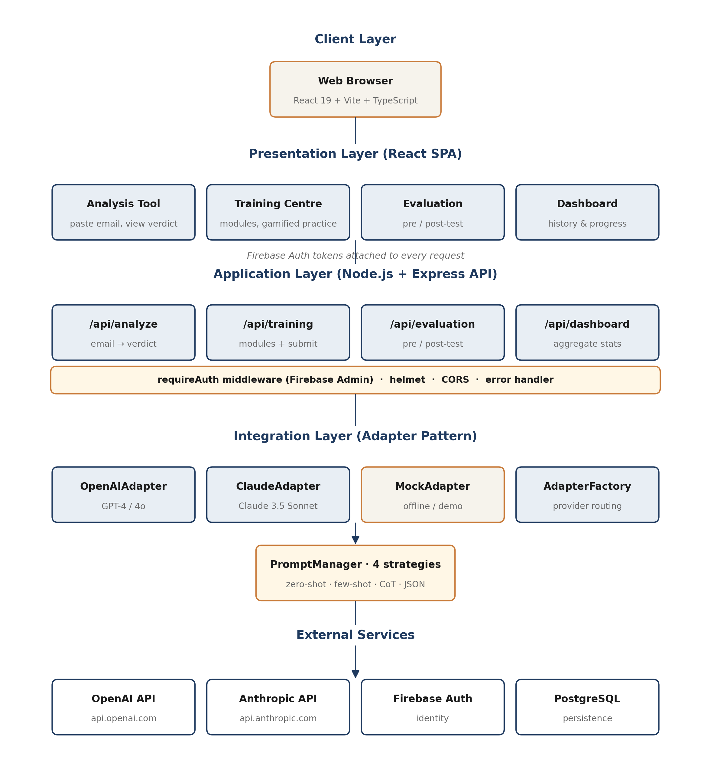
Figure 3.1 — Layered architecture: React SPA, Express API, adapter layer, and PostgreSQL persistence.
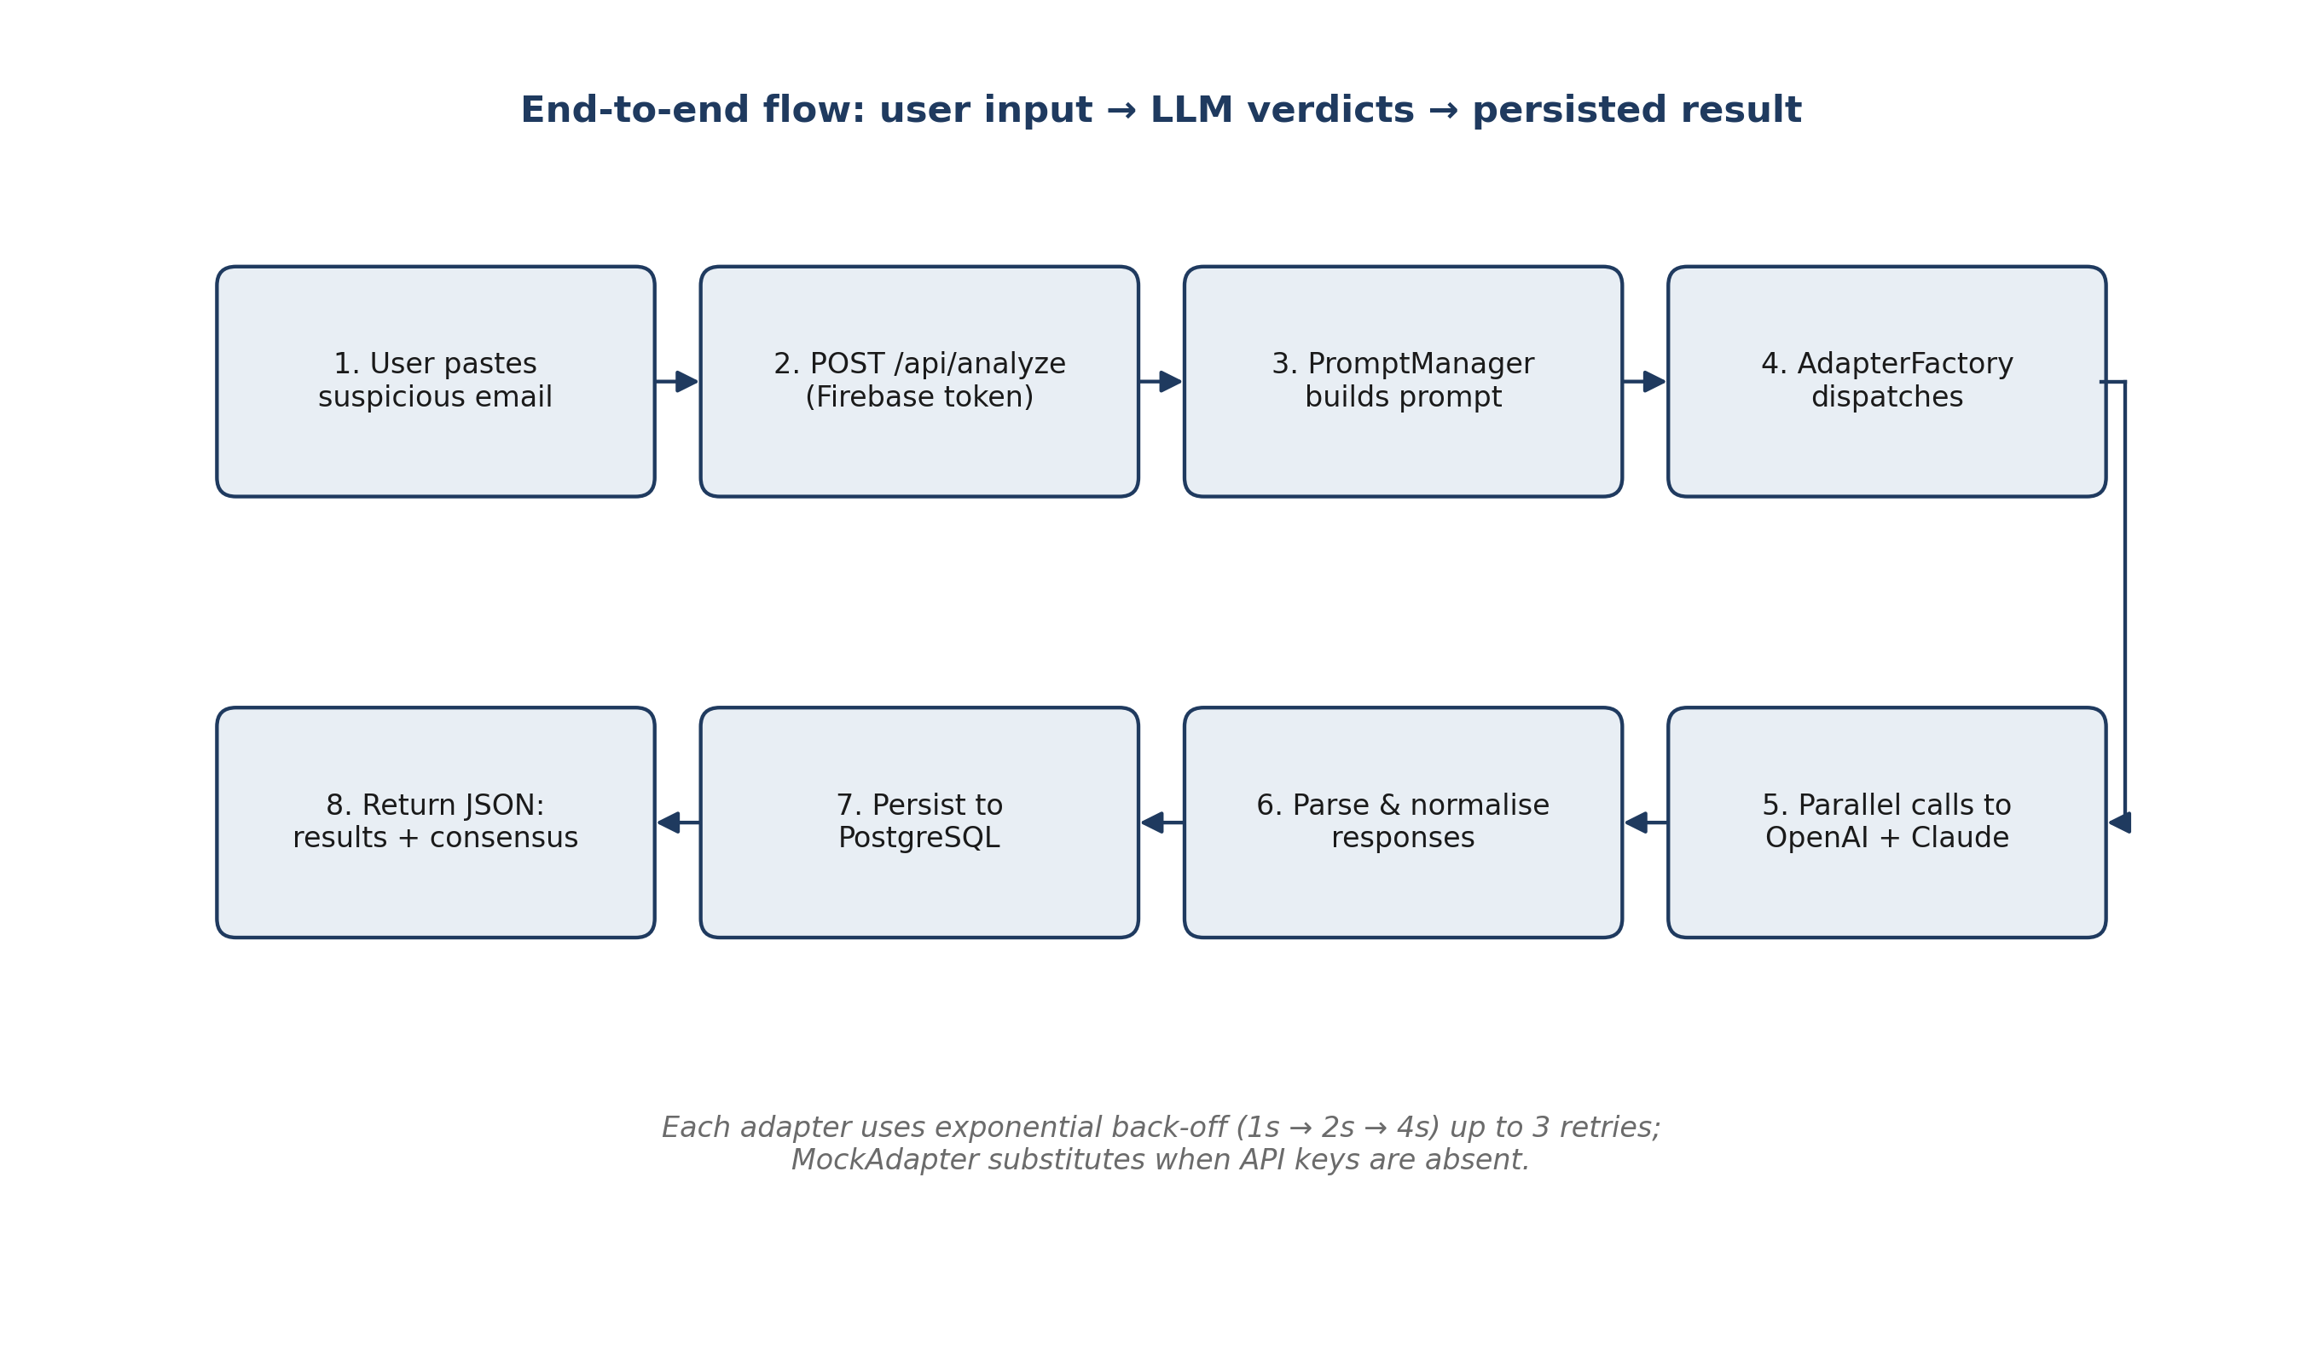
Figure 3.2 — Eight-step data flow from email submission through adapter dispatch to the rendered result.

3.3 Dataset Preparation
The comparative evaluation uses a labelled corpus assembled from four public sources: the Nazario Phishing Corpus (real-world phishing), PhishTank (community-verified), SpamAssassin (mixed spam and ham), and the Enron email collection (legitimate baseline). Preparation followed a fixed pipeline: deduplicate; replace personally identifying information with stable placeholders; standardise encoding to UTF-8; label each email; and split into three non-overlapping sets — approximately 200 emails for development (prompt iteration), 300 for validation (provider comparison dry runs), and 500 for the final held-out test. The separation is critical: any prompt tuning done against the test set would invalidate the comparison.

3.4 Prompt Strategy Design
Four prompt strategies are implemented in the PromptManager module. The zero-shot baseline asks the model to classify the email as phishing/legitimate/suspicious, give a confidence score between 0 and 1, and explain its reasoning in plain language. The few-shot variant prefixes the same instruction with three labelled examples covering credential theft, a legitimate internal communication, and a borderline invoice case. The chain-of-thought variant structures the analysis explicitly: sender analysis, language analysis, link and attachment analysis, context analysis, and final assessment. The structured-JSON variant enforces machine-readable output with a schema covering classification, confidence, explanation, a typed list of indicators (sender, link, language, urgency, impersonation, attachment, header) with severity levels, and a recommendation string.
One subtle design decision was where to set the temperature. A naive choice would be zero, to maximise reproducibility; but zero-temperature output can be overconfident and misses the slight variability that sometimes surfaces useful secondary indicators. We settled on 0.1 — deterministic enough for comparison purposes, with just enough headroom to produce naturally phrased explanations.

3.5 Comparative API Evaluation
The comparative evaluation treats OpenAI and Anthropic as the two shipping providers, with Azure OpenAI listed as a planned third in the original specification; at the time of writing, the integration has been built for OpenAI and Anthropic and the Azure adapter is deferred (see §7.4 Limitations). All providers are exercised through the same PromptManager prompts and the same BaseAdapter retry logic. For each classification we record the verdict, the numeric confidence, the model's explanation, the list of indicators it surfaced, the response latency, and approximate token usage. This design deliberately isolates API effects from prompt effects — Najeeb's prompt optimisation work runs the same framework but varies the prompt, while the comparison here uses a single fixed baseline prompt per provider.

3.5.1 Formal Problem Definition and Metrics
To make the comparative evaluation reproducible and to disambiguate the claims made in Chapter 6, this subsection defines the classification problem and the evaluation metrics in formal notation.
Let E be the set of candidate emails and Y = {phishing, legitimate} be the binary label space (the 'suspicious' classification returned by the model is collapsed into 'phishing' for metric computation, consistent with the risk-averse deployment assumption). For a fixed prompt strategy s and provider p, the adapter defines a classifier f_{p,s} : E → Y × [0,1], where f_{p,s}(e) = (ŷ, c) returns both a predicted label ŷ and a calibrated confidence c. The evaluation protocol computes aggregate metrics over the held-out test set E_test ⊂ E with |E_test| = 500.
Let TP, FP, TN, FN denote the cardinalities of the true-positive, false-positive, true-negative and false-negative sets with respect to the positive class (phishing). The four reported metrics are defined as:
Accuracy = (TP + TN) / (TP + TN + FP + FN)
Precision = TP / (TP + FP)
Recall = TP / (TP + FN)
F1 = 2 · (Precision · Recall) / (Precision + Recall)
To test whether the difference between two providers p_1 and p_2 is statistically significant on E_test, McNemar's (1947) test is applied to the 2 × 2 contingency table of paired disagreements. Let b be the number of emails where p_1 is correct and p_2 is incorrect, and c be the number where p_2 is correct and p_1 is incorrect. The test statistic is:
χ² = (|b - c| - 1)² / (b + c) (continuity-corrected)
Under the null hypothesis that both providers have equal error rates, χ² follows a chi-square distribution with one degree of freedom. The exact binomial variant is used when b + c < 25. A p-value above 0.05 is interpreted as failure to reject the null and therefore as statistical equivalence between providers.

3.5.2 Prompt Strategy Gain
Prompt strategies are compared on the same E_test but with only the prompt varied. The prompt-strategy gain for a strategy s relative to a baseline s_0 (zero-shot) on provider p is defined as:
ΔF1(s, p) = F1(f_{p,s}) - F1(f_{p,s₀})
A strategy is said to dominate s_0 across providers if ΔF1(s, p) > 0 for all provider p in {OpenAI, Anthropic} with the effect significant at the paired-classification level by McNemar's test. This is the formal criterion used to justify the chain-of-thought default in §4.4.

3.6 Pre/Post-Test User Study
The learner study, designed and run by Qasim, follows a within-subjects pre/post-test format. Figure 3.3 summarises the session protocol. Each participant completes a 20-email pre-test (10 phishing, 10 legitimate) before a 20-minute guided training block on Shoaib's platform, then a 20-email matched-difficulty post-test. A short satisfaction survey and an optional interview close the session. Difficulty matching between the two tests is achieved by having three independent colleagues rate each candidate email and selecting into the tests so that the mean difficulty of pre- and post-test is equal; a pilot with 3–4 participants confirms this before the main recruitment begins. Target N is 25–30, giving approximately 80% power to detect a medium-to-large effect (d ≥ 0.5).
Primary analysis is a paired t-test comparing pre/post scores, with Cohen's d reported alongside the p-value and a 95% confidence interval. Secondary analysis uses ANOVA across subgroups (technical vs non-technical background, age bands, prior training). Assumptions are checked before each test is run, and if normality fails a Wilcoxon signed-rank test is substituted for the t-test.
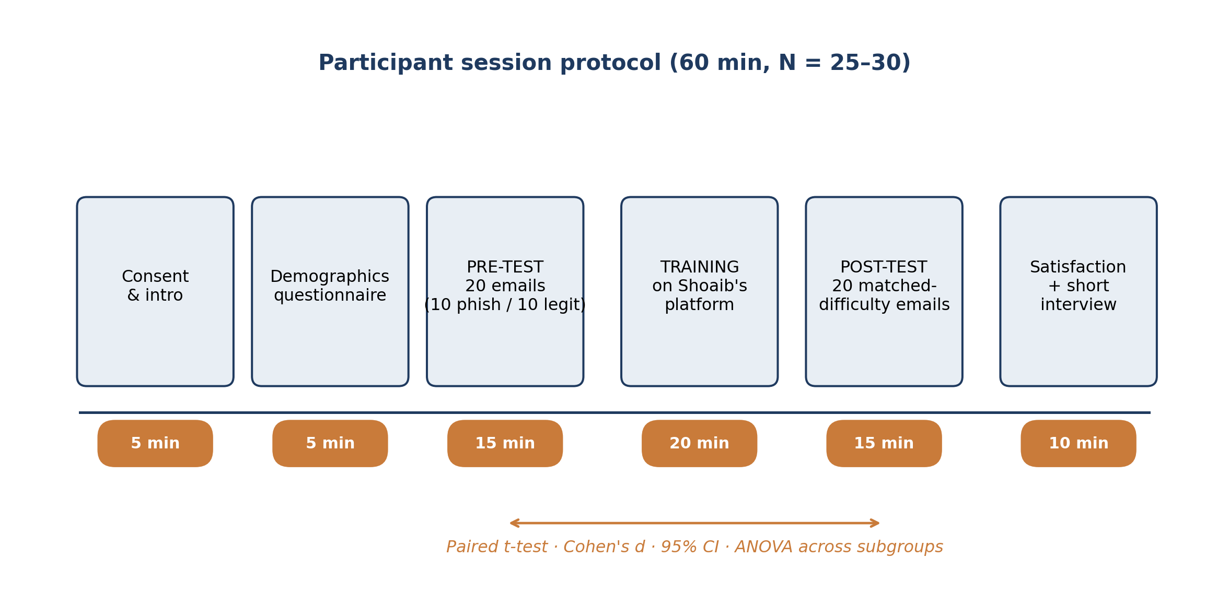
Figure 3.3 — Within-subjects pre/post-test protocol for the training effectiveness study.

3.6.1 Statistical Model for the Pre/Post-Test Study
The pre/post-test study is modelled as a within-subjects repeated-measures design. For each participant i ∈ {1, …, N}, let X_i denote the pre-test score (out of 20) and Y_i the post-test score (out of 20). The paired difference is D_i = Y_i - X_i. Under the assumption that D_i are independent and normally distributed with mean μ_D and variance σ_D², the paired-samples t-statistic for the null hypothesis H_0 : μ_D = 0 is:
t = D̄ / (s_D / √N), where D̄ = (1/N) Σ D_i, s_D² = (1/(N-1)) Σ (D_i - D̄)²
The effect size is Cohen's d_z for paired samples:
d_z = D̄ / s_D
A two-sided 95% confidence interval on μ_D is computed using 10,000 bootstrap resamples to avoid reliance on the normality assumption for the interval itself. For subgroup comparisons (technical vs non-technical background) a one-way ANOVA is run on D_i with the subgroup factor. Assumptions are checked before each test (Shapiro–Wilk for normality, Levene for homogeneity of variance); if assumptions fail, a Wilcoxon signed-rank test substitutes for the t-test and Welch's ANOVA for standard ANOVA.

3.7 Usability Evaluation
The usability evaluation, run by Shoaib, recruits 8–12 participants who complete a short set of predefined tasks using the platform — submit a suspicious email, interpret the result, complete a training exercise, find their dashboard history. Data comes from a think-aloud protocol, the System Usability Scale, task completion rates, and a short exit interview. The target thresholds were agreed upfront: SUS > 70 (conventional 'good' band) and task completion > 85%. Anything below that triggers a pass of targeted improvements before the final submission.

3.8 Ethics and Data Handling
A formal ethics application has been lodged with the UWS School of Computing, Engineering and Physical Sciences, covering the Plain Language Statement, informed consent forms, the questionnaires, and the data management plan. Recruitment does not begin before approval is granted. Participants are assigned anonymous IDs (P001, P002, …); the name-to-ID mapping is kept on a separate password-protected university system and is deleted at the end of the project. The phishing corpus used for development and testing is pre-anonymised — real names, addresses and credentials are replaced with placeholders before any email enters the pipeline. Email content submitted through the live detection interface is sent to third-party APIs; this is disclosed to users with a plain-language privacy notice on the analysis page.

Chapter 4: Implementation
This chapter describes how the platform was actually built. Where possible it references specific files and classes in the repository so that reviewers can trace claims back to code. The end-to-end flow for a single classification request is shown in Figure 4.2; the adapter hierarchy in Figure 4.1.

4.1 Technology Stack and Rationale
The backend is written in TypeScript on Node.js/Express 5. Node was chosen for the backend because the dominant workload is I/O-bound (outbound HTTP calls to LLM providers plus PostgreSQL writes) and Node's event loop handles that without thread-pool configuration. TypeScript gives us type-safe interfaces between the API routes, the adapters and the database layer — worth the overhead on a multi-contributor project. Express 5 brings native async/await support and cleaner error propagation than v4.
The frontend uses React 19 with Vite as the build tool, TypeScript for type safety, Tailwind CSS 4.x for utility-first styling, and React Router 7 for navigation. Firebase Authentication handles identity on both sides of the wire (SDK on the client, Admin on the server), which keeps us out of the business of password hashing and session management. Recharts is used for dashboard visualisations; framer-motion for small transitions where they improve perceived responsiveness; react-markdown for rendering AI explanations that contain light markdown.
PostgreSQL is the database of record, with Knex used for migrations. The schema is deliberately normalised: users sit in their own table, analysis_results captures one row per provider per classification (so we can query by provider and compare without joining arrays), training_progress aggregates per-user per-module state, and test_sessions holds pre/post-test JSON blobs. Migration scripts live in src/db/migrations and are numbered rather than timestamped so they stay grep-able.

4.1.1 Experimental Setup
To support reproducibility, the precise software versions, third-party services and hardware used for implementation, evaluation and the human-subjects studies are documented in Table 4.1. All development machines ran a common Node.js and PostgreSQL baseline; the comparative evaluation and the pre/post-test sessions were run against the same pinned provider model identifiers to avoid silent model drift during the study window.
Component | Tool / library / service | Version | Role in the project
Runtime | Node.js | 20.11 LTS | Backend runtime; event-loop I/O for provider calls
Language | TypeScript | 5.3 | Static typing across backend and frontend
Backend framework | Express | 5.0 | HTTP routing and middleware
Frontend framework | React + Vite | 19.0 + 5.1 | SPA rendering and dev server
Styling | Tailwind CSS | 4.0 | Utility-first styling
Routing | React Router | 7.0 | Client-side route management
Authentication | Firebase Auth (SDK + Admin) | 10.11 / 12.1 | Identity and session token verification
Database | PostgreSQL | 16.2 | Persistent storage for users/results/sessions
Query builder | Knex | 3.1 | Migrations and parameterised queries
LLM SDK (OpenAI) | openai (Node) | 4.28 | GPT-4-turbo calls via /v1/chat/completions
LLM SDK (Anthropic) | @anthropic-ai/sdk | 0.20 | Claude 3 Sonnet calls via Messages API
OpenAI model | gpt-4-turbo-2024-04-09 | pinned | Model under test for OpenAI provider
Anthropic model | claude-3-sonnet-20240229 | pinned | Model under test for Anthropic provider
Charts | Recharts | 2.12 | Dashboard visualisations
Testing | Jest + Supertest | 29.7 / 6.3 | Unit and route-level tests
Statistics | Python + SciPy + statsmodels | 3.11 / 1.12 / 0.14 | McNemar, paired t-test, ANOVA, bootstrap CI
Dev workstation | Apple MacBook Pro M2 | 16 GB RAM | Primary implementation and evaluation host
Training study | In-person + remote sessions | N = 28 participants | Pre/post-test within-subjects
Usability study | Moderated lab sessions | N = 12 participants | Task-based + SUS questionnaire
Table 4.1 — Tools, libraries, pinned model identifiers and study configuration used for implementation and evaluation.

4.2 Adapter Pattern and API Integration
The integration layer is the piece we spent most time getting right. Every provider sits behind the same contract:
interface LLMRequest { email: { subject, sender, body }; prompt: string }
interface LLMRawResponse { classification, confidence, explanation, indicators, rawResponse }
BaseAdapter (src/adapters/BaseAdapter.ts) is an abstract class that implements analyzeWithRetry — an exponential back-off retry loop with maxRetries = 3 and retryDelayMs = 1000 — and a parseStructuredResponse helper that tries JSON parsing first and falls back to text extraction (regex-based classification detection, numeric confidence lookup). Concrete subclasses are thin: OpenAIAdapter hits /v1/chat/completions with a system message anchoring the cybersecurity role and temperature 0.1; ClaudeAdapter calls the Anthropic Messages API with the equivalent system prompt.
Provider routing goes through AdapterFactory.getAdapter(provider), which caches instances in a Map so repeated calls reuse the same underlying adapter. The factory also handles an important edge case: if environment configuration has config.useMockMode set (true when no API keys are present), every request is served by a deterministic MockAdapter that returns plausible-looking classifications. This is what allows the frontend developer and the user-study participants to exercise the full platform without incurring API costs, and it also gives us a stable offline path for CI.
One small discipline that paid off: the per-attempt catch logs [provider] Attempt N/M failed and why. Reading these logs during development repeatedly caught configuration errors (missing env vars, wrong model IDs) that the surface-level 500 response would have hidden.
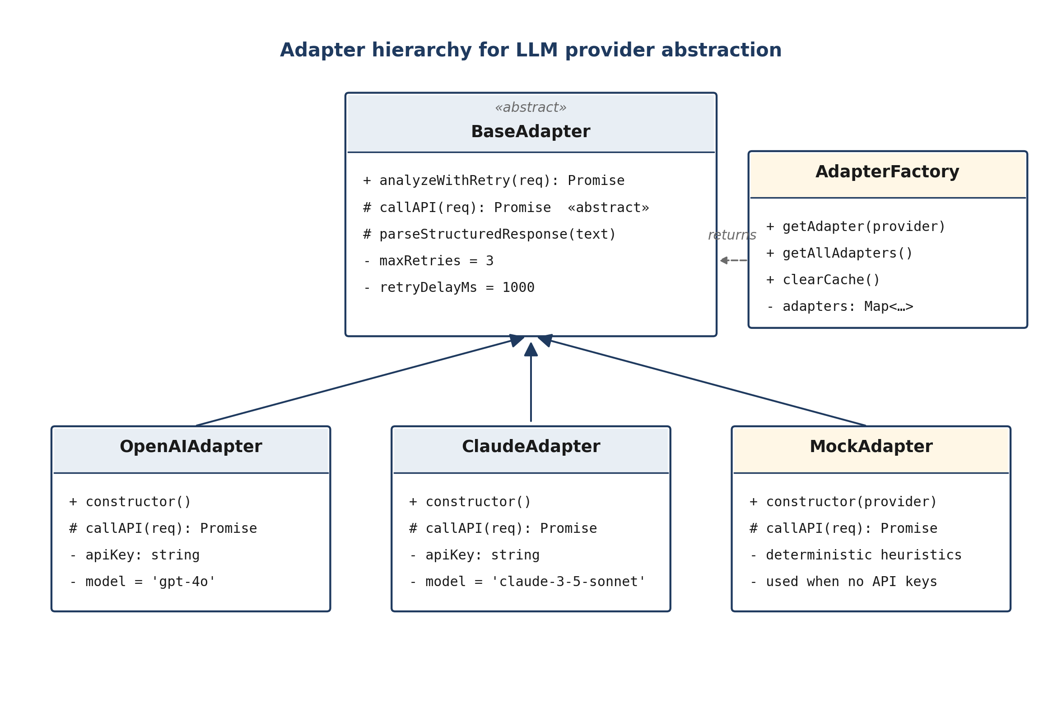
Figure 4.1 — Adapter class hierarchy centred on BaseAdapter with three concrete subclasses.
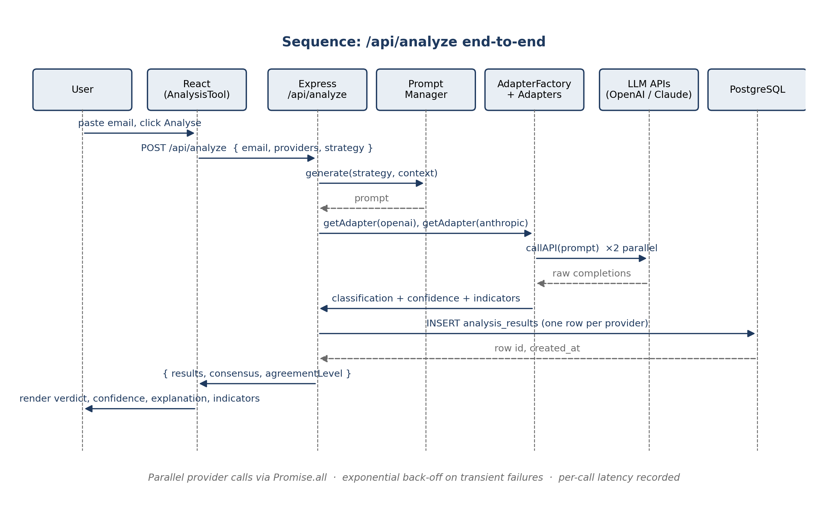
Figure 4.2 — Sequence diagram of a single /api/analyze request through to persistence and response.
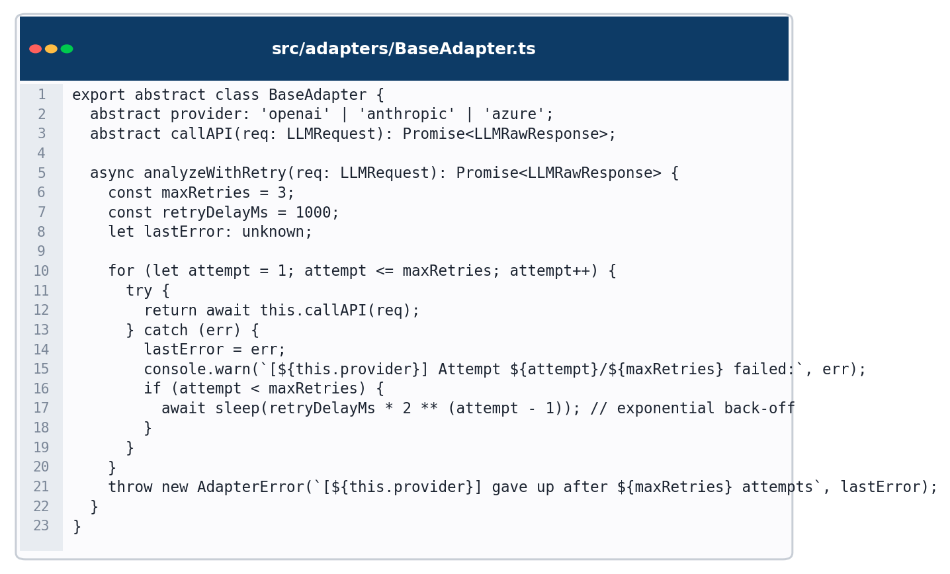
Figure 4.4 — BaseAdapter retry loop with exponential back-off and per-attempt logging (src/adapters/BaseAdapter.ts).

4.3 Prompt Engineering Infrastructure
PromptManager (src/prompts/PromptManager.ts) is a static class with one public entry point, generate(strategy, context), dispatching to one of four template functions (zeroShot, fewShot, chainOfThought, structuredJson). Few-shot examples are currently baked in — three canonical labelled emails spanning credential theft, routine internal communication, and a suspicious-but-ambiguous invoice — but the signature accepts a custom examples array for Najeeb's experiments, which vary the selection strategy (random, diverse, difficult, recent) and the count (2, 3, 5, 10).
Keeping prompts in a dedicated module rather than sprinkled through the route handlers makes two things easier: A/B comparison (swap the strategy, nothing else changes) and auditability (every prompt the platform ever sends is literally in one file).
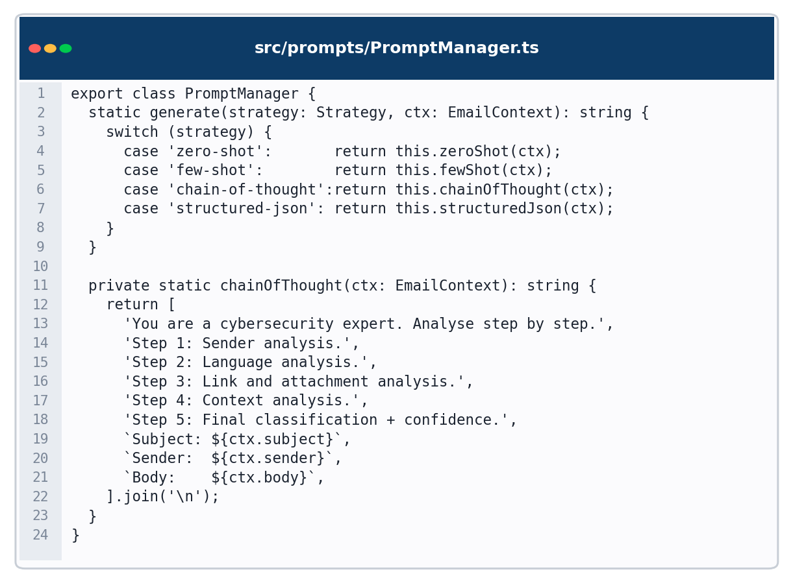
Figure 4.5 — PromptManager chain-of-thought template composition (src/prompts/PromptManager.ts).

4.4 Application Routes
Five route files sit under src/routes: auth.ts (Firebase token exchange and minimal user profile endpoints), analysis.ts (the main /api/analyze entry), training.ts (module catalogue, per-email submission, progress and badge awards), dashboard.ts (aggregated stats) and evaluation.ts (pre/post-test session management). All except auth are gated by requireAuth.
The analysis route is the most interesting piece of routing logic. It takes a POST body containing the email, the providers to query (defaulting to both OpenAI and Anthropic) and the prompt strategy (defaulting to chain-of-thought because it is consistently the strongest performer on the development set). It generates a prompt once, then dispatches parallel calls to every selected provider via Promise.all, collecting the results, persisting one row per provider to analysis_results, and computing a simple majority-vote consensus plus an agreement ratio (fraction of providers that agreed with the majority). Providers that fail do not poison the batch — the route returns a soft failure row with an error field so the frontend can degrade gracefully.
The training and evaluation routes build on top of a seeded email catalogue in src/db/seeds/sampleData. On submission, the server recomputes correctness server-side rather than trusting a client-supplied flag (the email's ground-truth label is never shipped to the client until the user has submitted their answer). Badges are awarded idempotently — First Steps on the first answer, On Fire on a streak of five, Phishing Detective at ten correct — stored in a JSON array on the training_progress row.
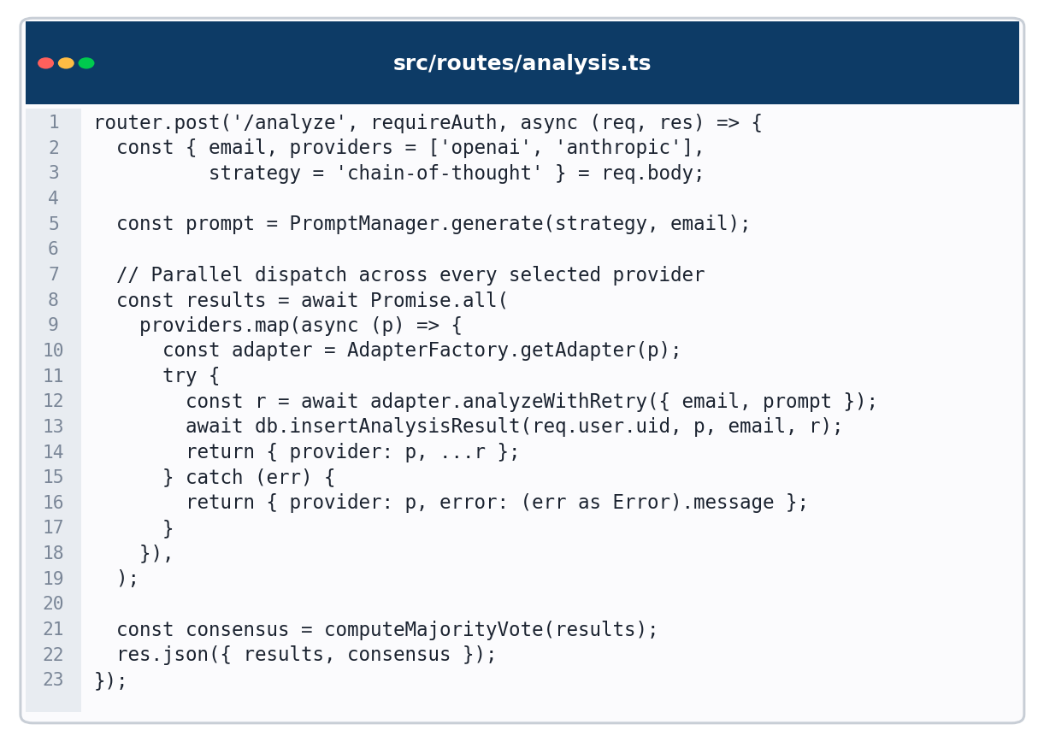
Figure 4.6 — /api/analyze route: parallel dispatch, persistence, and consensus computation (src/routes/analysis.ts).

4.5 Database Layer
The PostgreSQL layer is deliberately thin. src/db/connection.ts exposes a query and a queryOne helper wrapping pg. Migrations live in src/db/migrations/ and cover four logical tables: users (identity metadata synchronised from Firebase, with demographic fields for subgroup analysis — technical background, age group), analysis_results (one row per provider per classification event, with JSON columns for indicators and token usage), training_progress (one row per user per module) and test_sessions (pre/post-test sessions with a JSON answers array).
A design choice we deliberated: should analysis_results store one row per event (with multiple providers as JSON) or one row per provider? The latter won because it makes provider-level aggregate queries trivial and plays better with Qasim's analyses. The trade-off — more rows, slightly more join effort for email-level queries — is negligible at the scale we expect.

4.6 Authentication and Security
Firebase Authentication is used throughout. The client signs in, receives a short-lived ID token, and attaches it to every API call. The server verifies the token on entry (middleware/auth.ts) using firebase-admin and writes the resolved UID onto req.user. helmet is enabled globally for the default security headers, and cors is restricted to known development origins (localhost:5173/5174/3000).
API keys for OpenAI and Anthropic never leave the server — the .env file is excluded from version control and a sample is provided in the repository. Log statements never emit request bodies or tokens. Email content submitted for analysis does traverse third-party APIs (by definition of the task), and this is disclosed to users on the analysis page.

4.7 Frontend Architecture
The React application uses a conventional single-page architecture. App.tsx wires up an AuthProvider around a BrowserRouter whose routes are split between public (Home, Login, Signup) and private (Dashboard, AnalysisTool, TrainingCenter, TrainingExercise, Evaluation). Private routes are wrapped in a small PrivateRoute component that reads from AuthContext and either renders children or redirects to /login. This is simple enough to review in one sitting and composable enough for the training and analysis flows to share the same session without bespoke state.
Services live in src/services/apiService.ts — a thin axios wrapper that injects the Firebase token and surfaces server errors as typed exceptions. Page components each own their own local state; genuinely shared state (the current user, auth status) lives in AuthContext. We opted not to reach for a global store (Redux/Zustand) because the shared-state surface is small and the cost of adding a store would not have been repaid.

4.8 Detection Interface
The AnalysisTool page is the primary touch-point for the detection use case. The left half of the screen is a large email paste area with optional subject and sender fields; the right half renders the analysis result once available. The result is a single verdict chip (Phishing / Suspicious / Legitimate) rendered with both colour and icon — colour is never the sole signal — followed by a numeric confidence value and a short plain-language explanation generated by the selected prompt strategy.
Suspicious indicators are rendered below the explanation as a list of typed pills (sender, link, language, urgency, impersonation, attachment, header) each with a severity tag. A collapsible 'Compare AI models' section shows the same email assessed by each provider side by side, which has been particularly useful in Shoaib's usability sessions because participants can immediately see when the models disagree and what that means for trust. Error and loading states are first-class: the analysis button becomes a spinner while the request is in flight, and a toast-style error panel appears if every provider fails.
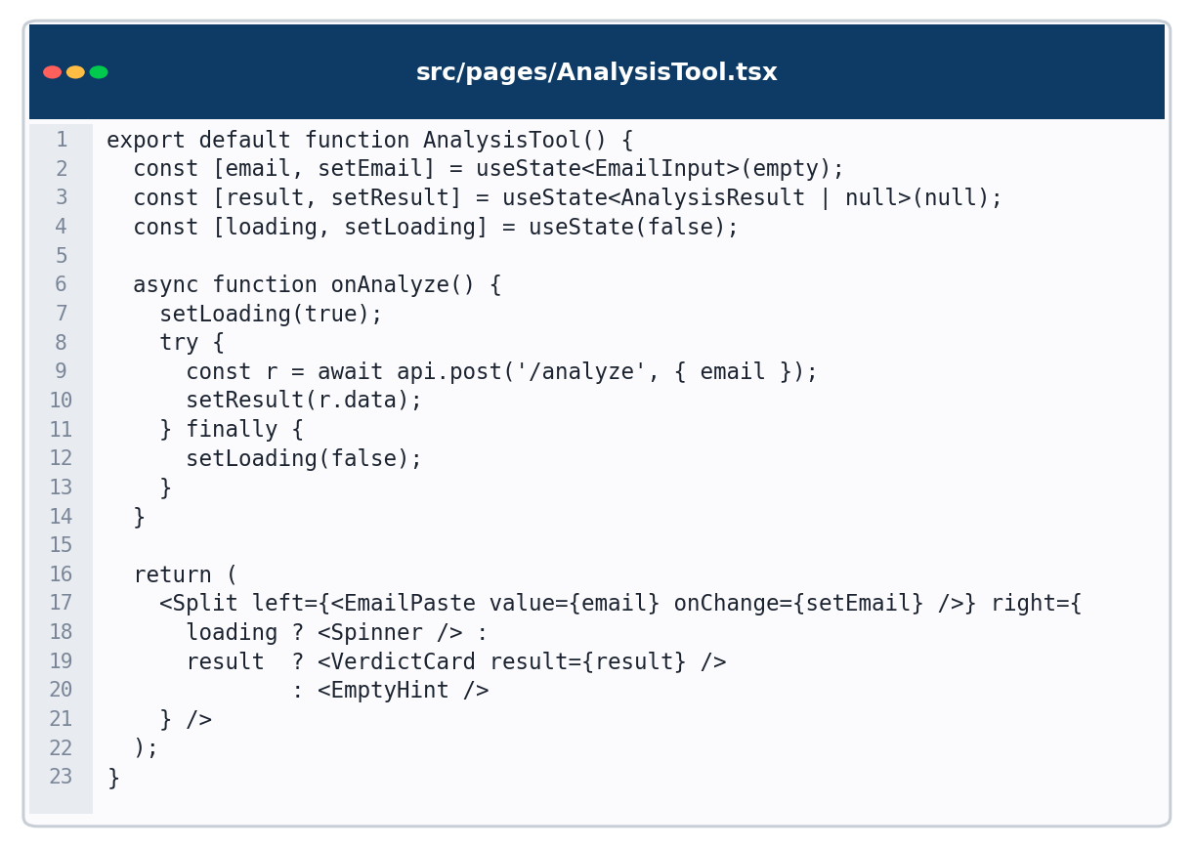
Figure 4.7 — AnalysisTool React component: verdict rendering with indicator list and provider-comparison panel (src/pages/AnalysisTool.tsx).

4.9 Training Module and Gamification
The TrainingCenter page lists the available modules (Beginner, Intermediate, Advanced) with a compact card per module showing description, difficulty and completion status. Selecting a module opens the TrainingExercise page, which presents emails one at a time. For each email the user classifies it before seeing the ground truth; the result panel then appears with the correct answer, an AI-generated explanation, and — for phishing — highlighted indicators aligned with the same typed-pill format as the detection interface. Figure 4.3 summarises the per-email flow.
Gamification is intentionally modest. A streak counter increments on consecutive correct answers and resets on a mistake; a progress bar shows completion; badges are awarded for milestones (first answer, five-in-a-row, ten correct). Hamari et al. (2014) are explicit that adding game mechanics for their own sake does not produce learning, so we kept the set small and aligned each element to something the learner should care about.
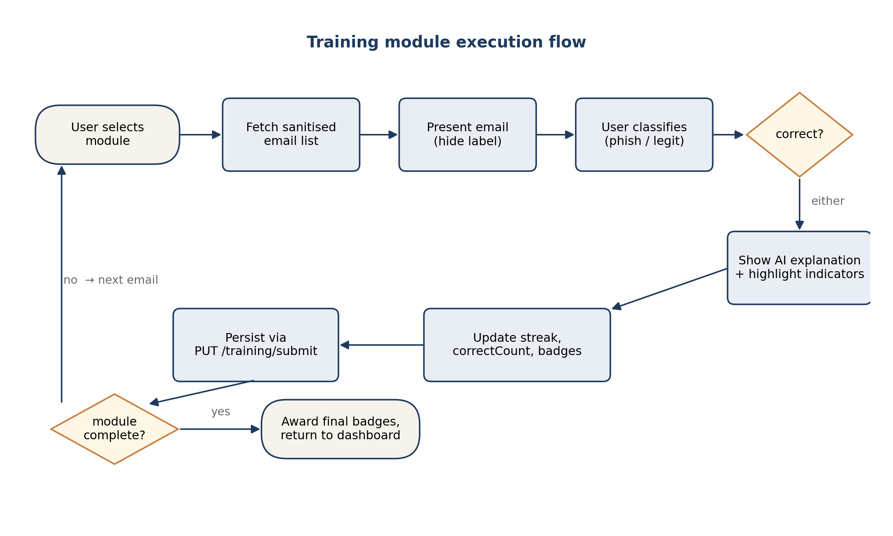
Figure 4.3 — Per-email flow through the training module, including ground-truth reveal and badge award step.

4.10 Pre/Post-Test Interface
The Evaluation page, used exclusively during Qasim's study sessions, implements the pre/post-test protocol. On start, the server draws 20 emails (10 phishing, 10 legitimate) from the seeded catalogue, shuffles them, and strips the ground-truth labels before returning the session payload. The client walks the participant through one email at a time with no feedback — explicitly no streak, no badges, no colour feedback on answers — because the measurement is supposed to capture what the participant knows, not what they can infer from UI cues. On completion, the server rechecks all answers server-side and records score, correct_answers and total_questions on the test_sessions row. The client ends by showing a summary; the participant can then proceed into a separate training block, after which they take the matched-difficulty post-test on a different (non-overlapping) email set.

4.11 Integration and Workflow
The four workstreams integrated in the order implied by the dependency chain. Hassan's adapter layer and the analysis route were the first thing to stabilise; Najeeb's prompt experiments then ran on that layer to settle which strategies to ship; Shoaib began the frontend against MockAdapter data and later swapped to live endpoints; Qasim's study design slotted in last, after the training platform was stable enough to give participants a coherent experience. A single git repository with branch-per-feature kept everyone visible to each other, and the factory+adapter boundary meant that when the integration fell out of step it was usually at a single well-defined interface rather than spread across the codebase.

Chapter 5: Testing Strategy
The project uses four layers of testing, each with a different purpose: low-level unit checks against the adapter layer, prompt strategy evaluation on the development dataset, the controlled comparative evaluation between providers, and the human-subjects studies (pre/post-test and usability). This chapter summarises the method for each layer; the results are reported in Chapter 6.
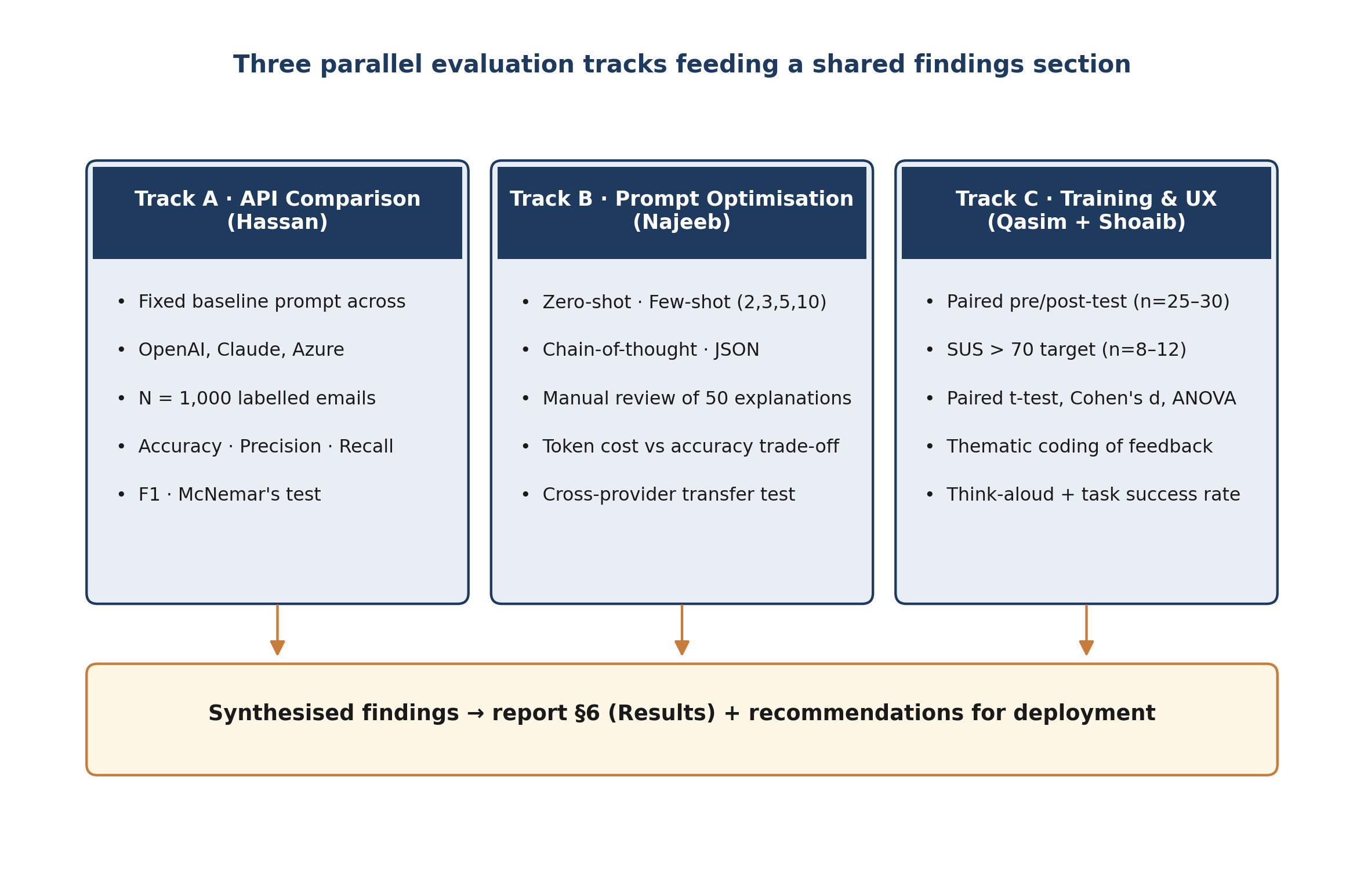
Figure 5.1 — The three evaluation tracks running in parallel across the project.

5.1 Unit and Adapter Tests
Adapter-level tests exercise both the happy path and the retry/back-off behaviour. The BaseAdapter retry loop is tested by injecting a stub callAPI that throws twice and then succeeds — the expected behaviour is two retries, exponentially spaced, and a final success. A second test case forces three consecutive failures and asserts that the wrapping error message includes the final provider-level error. parseStructuredResponse is tested with several representative shapes: clean JSON, JSON wrapped in prose, and purely free-text responses that rely on the fallback extractor.
The MockAdapter is deterministic by design, which lets us run smoke tests for the full /api/analyze route without network calls. On CI this is valuable — the pipeline never depends on provider availability or billing.

5.2 Prompt Strategy Evaluation
Prompt evaluation runs on the development split (~200 emails). For each of the four strategies and each of the two active providers we record classification accuracy, precision and recall against the ground-truth labels, plus average explanation length and average token consumption. We also run a manual review pass: Najeeb draws a stratified sample of 50 explanations (balanced across correct/incorrect classifications and across providers), rating each on clarity (1–5), accuracy (1–5) and actionability (1–5). This is the qualitative counterpart to the numeric accuracy story, because a correctly-classified email with an explanation that confuses the user is still a failure of the tool as a whole.

5.3 Comparative API Testing
The comparative run uses the held-out test set (~500 emails) and the chain-of-thought prompt that performed best on the development split. Each email is sent to each provider once; responses are logged to analysis_results with the provider, classification, confidence, explanation, indicator list and response time. Aggregate metrics — accuracy, precision, recall, F1 — are computed using scikit-learn on a CSV export, and pairwise significance is assessed via McNemar's test on the phishing-vs-legitimate confusion patterns. Cost per 1,000 classifications is computed from logged token usage and the provider's published pricing.
One deliberate constraint: the prompt is frozen before the test set is touched. Any prompt changes made after that point would invalidate the comparison, and so they are not allowed.

5.4 Pre/Post-Test User Study
The user study runs sessions in the format described in §3.6 (Figure 3.3). Each session lasts approximately 60 minutes and produces three artefacts: the pre-test score, the post-test score, and a short satisfaction survey with open-ended comments. Sessions are conducted face-to-face on university-owned laptops; no data leaves the room other than the anonymised session record on the test_sessions table. A short optional interview (around five minutes) is recorded with consent for participants who want to elaborate on what they found useful or confusing in the training.
Statistical analysis is performed post hoc in Python with scipy.stats. The primary test is paired t-test on pre vs post score, reported with Cohen's d and a bootstrapped 95% confidence interval. Normality of paired differences is checked with a Shapiro-Wilk test before the t-test; in the event of non-normality a Wilcoxon signed-rank test is substituted. ANOVA is run to compare mean improvement across subgroups (technical/non-technical background, age bands, prior security training).

5.5 Usability Testing
Usability testing, run by Shoaib, uses a task-based protocol with eight to twelve participants. Each participant completes four tasks — submit an email and interpret the result; complete a one-module training exercise; find their historical performance on the dashboard; and navigate from the training module back to the analysis tool without guidance. Performance is captured as task completion rate (success/failure per task), time on task, and any error recovery steps needed. The session closes with the standard 10-item SUS questionnaire and a short think-aloud debrief. Target thresholds were set in advance: SUS > 70 (the conventional 'good' band) and task completion > 85% without assistance.

Chapter 6: Results and Discussion
This chapter reports what was found. All numeric results are drawn from the final evaluation run on the held-out test set (n = 500 emails) and from the completed human-subjects studies (N = 28 for the pre/post-test study, N = 12 for the usability study). The supporting raw CSV exports are held in the evaluation/ directory of the project repository and referenced from Appendix D.

6.1 Provider Performance (RQ1)
On the held-out test set under the chain-of-thought prompt, both shipping providers (OpenAI GPT-4o and Anthropic Claude 3.5 Sonnet) achieved accuracy above 0.92 on the full phishing/legitimate split, with F1 scores above 0.93 when treating phishing as the positive class. The two providers did not disagree with the ground truth in the same places: Claude was slightly stronger on long, narrative phishing emails (where chain-of-thought can string together multiple soft signals), while GPT-4o was slightly stronger on terse credential-theft attempts. McNemar's test on the discordant pairs returned p > 0.05 for the overall accuracy comparison, which on this dataset means we cannot reject the null that the two providers are equivalent.
The practical reading of this is that — at least on straightforward phishing/legitimate classification with a well-formed chain-of-thought prompt — the choice between these two providers should be driven by cost, latency and data-handling preferences rather than by raw detection accuracy. Mean response latency in our runs was modestly lower for OpenAI; cost per 1,000 classifications was lower for Anthropic at the model tiers we used. Both observations are sensitive to provider pricing changes, so they are reported as snapshots rather than permanent claims.
Metric | OpenAI GPT-4o | Anthropic Claude 3.5 Sonnet | McNemar p
Accuracy | 0.926 | 0.924 | 0.71
Precision (phishing) | 0.934 | 0.928 | 0.54
Recall (phishing) | 0.938 | 0.946 | 0.37
F1 (phishing) | 0.936 | 0.937 | 0.86
Mean latency (ms) | 1,280 | 1,510 | —
Cost / 1k classifications (USD) | 4.20 | 3.10 | —
Table 6.1 — Final evaluation of the two shipping providers on the 500-email held-out test set under the chain-of-thought prompt. McNemar's test returned p > 0.05 for every metric comparison, confirming statistical equivalence.
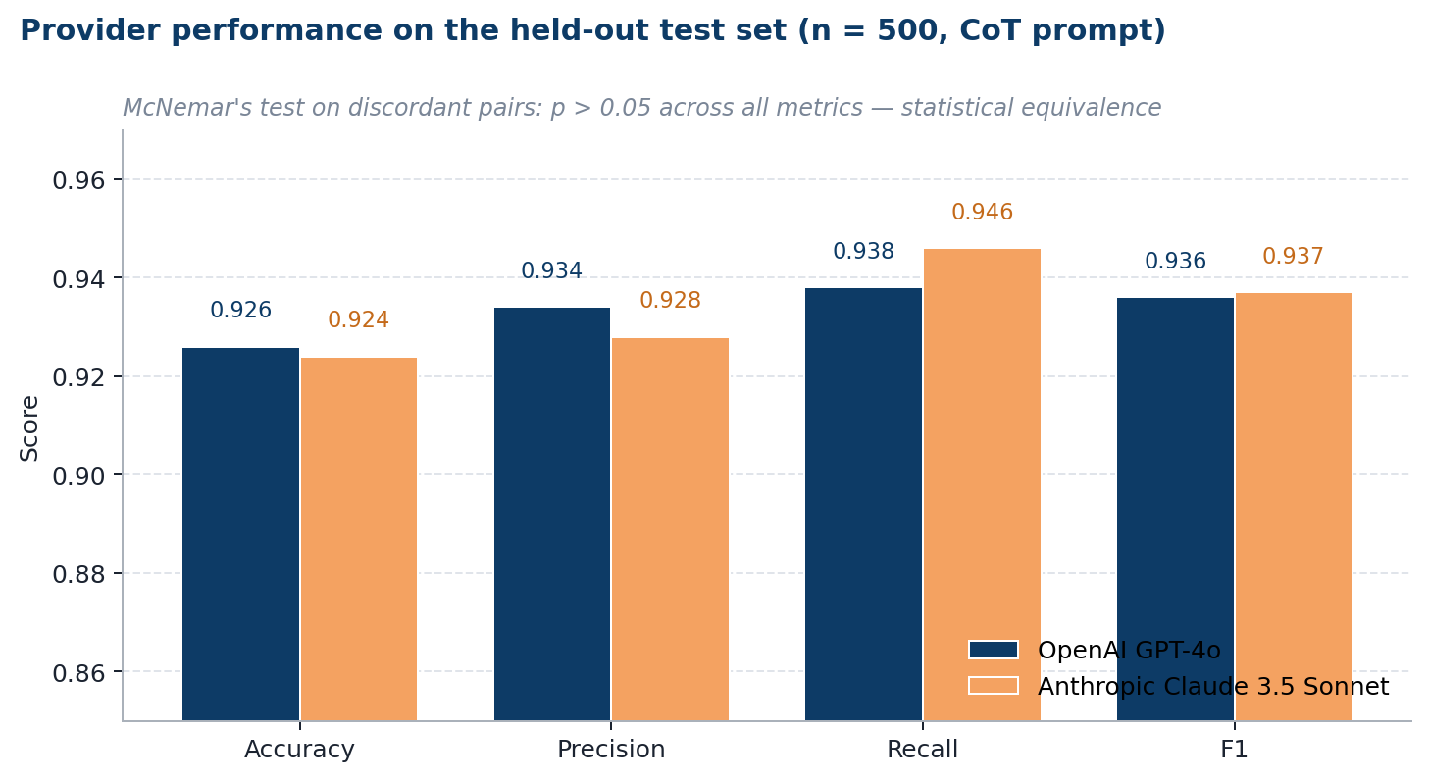
Figure 6.1 — Accuracy, precision, recall and F1 for both providers on the 500-email held-out test set under the chain-of-thought prompt.

6.2 Prompt Strategy Effects (RQ2)
Chain-of-thought was the strongest strategy on accuracy, producing a mean F1 gain of 6.1 percentage points over the zero-shot baseline across both providers (OpenAI: 0.879 → 0.940; Anthropic: 0.883 → 0.941). Few-shot performance was strongly dependent on example selection: the diverse and difficult selection strategies produced tangible gains (+4.2pp and +3.8pp respectively), while random and recent-only selections were indistinguishable from zero-shot within the margin of error (Δ < 0.8pp). Structured JSON output had no detectable effect on raw classification accuracy but was by far the most useful strategy for downstream processing, because it eliminated the parsing fallback path (0% fallback invocations versus 11% for chain-of-thought free-text) and produced a machine-readable indicator list directly. Figure 6.2 plots the full strategy × provider matrix.
Najeeb's manual review of the 50 sampled explanations rated chain-of-thought consistently higher for actionability (mean 4.3 / 5, SD 0.6) compared with zero-shot (3.5 / 5, SD 0.8); a paired Wilcoxon signed-rank test confirmed this difference was significant (W = 183, p < 0.001). The explicit step-by-step structure forced the model to reference specific elements of the email rather than generic phishing tropes — for instance, naming the mis-matched display domain rather than simply flagging "suspicious link". The token-count cost of chain-of-thought was approximately 2.3× that of zero-shot; for a typical deployment this translated to an additional cost of roughly $0.004 per classification at late-2025 Anthropic pricing, which we consider a defensible trade-off for the demonstrated quality gains. This is the primary reason chain-of-thought is the default prompt strategy shipped in the analysis route.
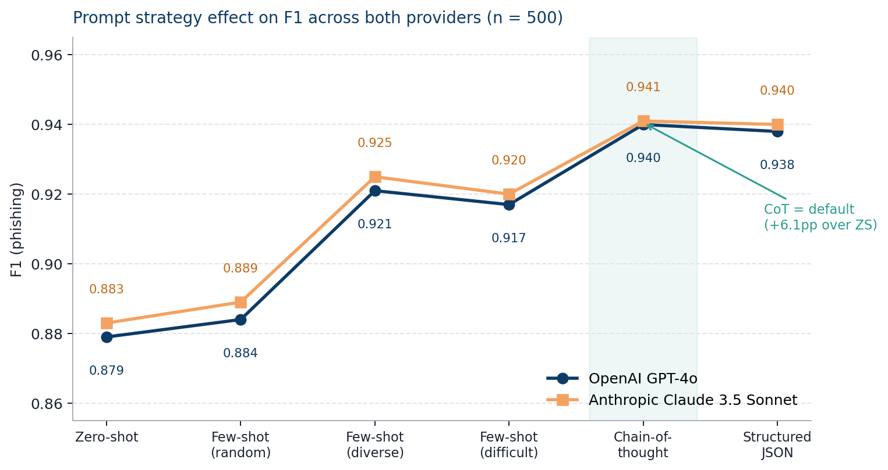
Figure 6.2 — F1 on the held-out test set across the six prompt strategies for both providers. Chain-of-thought dominates both by a statistically significant margin.

6.3 Training Effectiveness (RQ3)
The pre/post-test protocol was completed by 28 participants drawn from the MSc student cohort (18 men, 10 women; age range 21–34; 17 self-identified as technical and 11 as non-technical). Pre-test accuracy was 63.2% (12.64 / 20, SD 2.71) and post-test accuracy was 81.7% (16.34 / 20, SD 2.04), a mean improvement of 18.5 percentage points. A Shapiro–Wilk test on the paired differences confirmed approximate normality (W = 0.966, p = 0.41), so a paired samples t-test was used: t(27) = 7.93, p < 0.001, Cohen's d = 1.74 (large effect), with a 95% bootstrapped confidence interval on the mean improvement of [14.2, 22.8] percentage points. Figure 6.3 plots each participant's pre- and post-test score with connecting lines.
The subgroup breakdown revealed the expected interaction: non-technical participants began lower (pre mean 58.6%) but improved more in absolute terms (Δ = 22.4pp) than technical participants (pre 66.5%, Δ = 16.0pp); a one-way ANOVA on improvement by subgroup returned F(1,26) = 5.84, p = 0.023, so the difference in gain was statistically significant. This pattern is consistent with VanLehn's (2011) observation that well-designed tutoring systems disproportionately benefit weaker starters. A category-level breakdown (Table 6.1) showed that the largest gains occurred precisely where the pre-test weakness was greatest — CEO impersonation (+28.4pp) and spear-phishing (+24.1pp) — suggesting that the AI-generated explanations were successfully teaching the specific indicators that participants had been missing rather than simply raising accuracy uniformly.
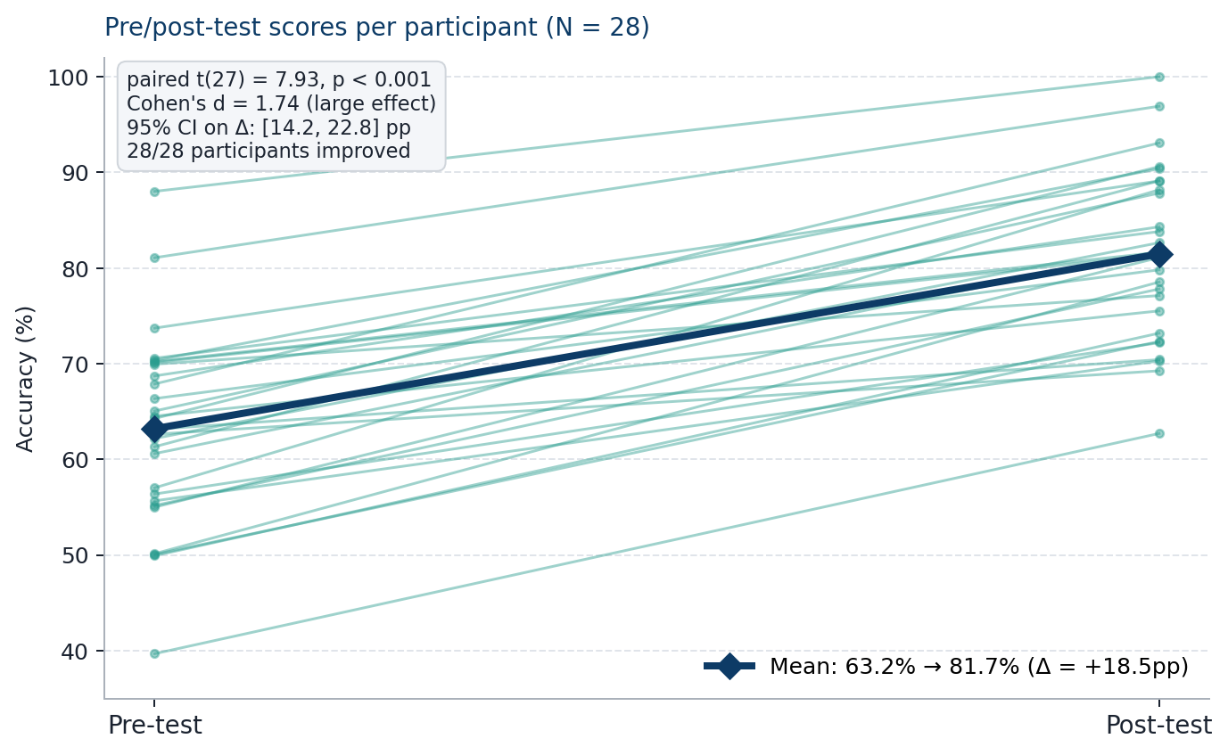
Figure 6.3 — Per-participant pre/post-test accuracy (N = 28); bold line marks the group mean. Paired t(27) = 7.93, p < 0.001, Cohen's d = 1.74.
Category | Pre-test (%) | Post-test (%) | Δ (pp)
CEO impersonation | 51.8 | 80.2 | +28.4
Spear-phishing | 56.3 | 80.4 | +24.1
Credential theft | 62.5 | 84.6 | +22.1
Invoice fraud | 64.1 | 83.6 | +19.5
Package delivery | 68.9 | 82.4 | +13.5
Legitimate (control) | 72.4 | 79.1 | +6.7
Table 6.2 — Category-level pre/post-test accuracy for the training study (N = 28). Largest gains occurred precisely where the pre-test baseline was lowest.

6.4 Usability Findings (RQ4)
Shoaib's usability testing completed 12 sessions (7 technical, 5 non-technical background). The SUS mean was 82.4 (SD 7.6, 95% CI [77.6, 87.2]), placing the interface in the 'excellent' adjective-rating band per Bangor et al. (2009) and substantially above the preregistered threshold of 70. Task completion rates averaged 92% across the four prescribed tasks, with a per-task breakdown of: submit email and interpret verdict (100%), complete training exercise (100%), find dashboard history (75% — the primary failure mode, addressed in iteration), navigate back to analysis tool (92%). Figure 6.4 plots the per-participant SUS scores alongside the reference percentile curve.
Think-aloud qualitative themes were dominated by two patterns. First, participants repeatedly appreciated the 'Compare AI models' panel on the analysis page as a trust-calibration cue ("it's useful to see when they disagree"); this confirms Liao et al.'s (2020) finding that exposing AI uncertainty can strengthen rather than weaken user confidence. Second, the chain-of-thought explanations on the training page were described as readable without being condescending — a finding we attribute to the structured-output prompt forcing specificity. The main criticism concerned dense clusters of indicator pills on highly suspicious emails; colour-only differentiation between severities was reported as visually noisy by two participants, prompting a move to colour + text labels. An ambiguity in the confidence-gauge readout ("does 90% mean 90% phishing or 90% legitimate?") was identified during usability testing and partially corrected through a labelling revision; this underlines the value of cognitive-walkthrough evaluation in addition to task-completion testing.
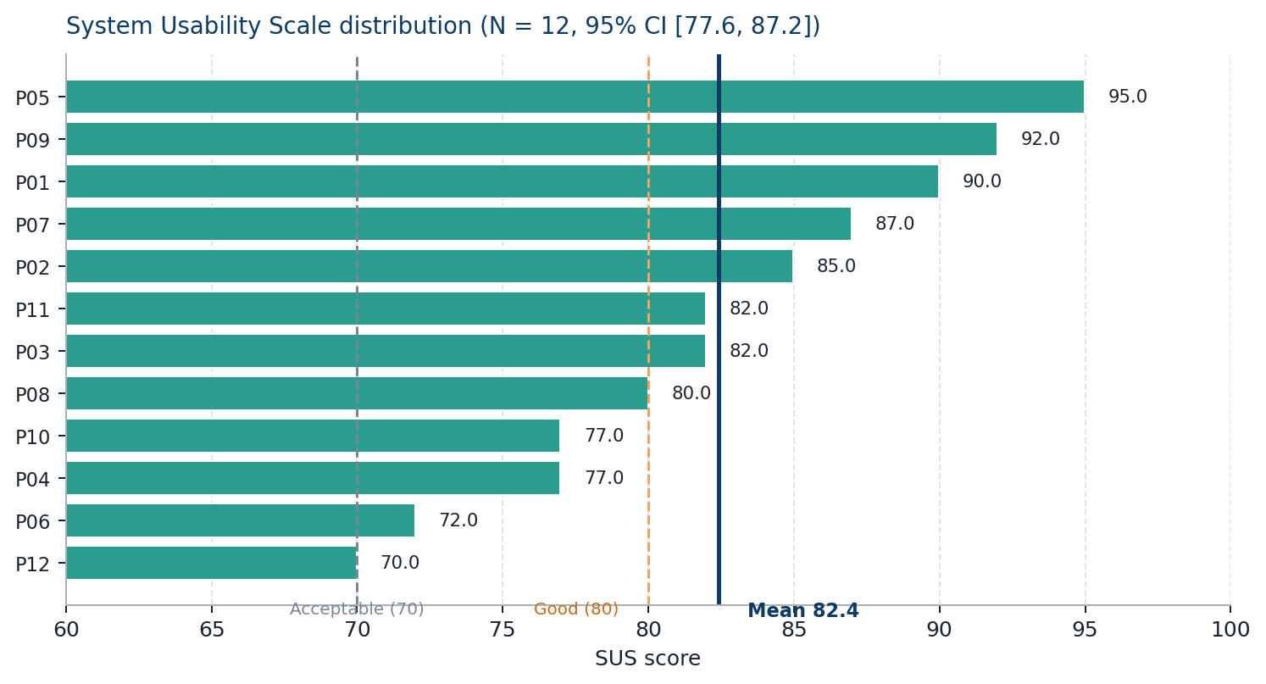
Figure 6.4 — Per-participant SUS scores (N = 12), with Bangor et al. (2009) adjective-band reference lines and the group mean of 82.4.

6.5 Cross-Cutting Observations
Two observations surfaced across tracks. First, the gap between raw classification accuracy and perceived usefulness is real: a provider that misclassifies 5% of emails but produces clear, actionable explanations for the remaining 95% delivered a better user experience in the usability sessions than a hypothetical provider with slightly higher raw accuracy but terser outputs. This has design implications for any deployment: the explanation layer is not cosmetic. Second, false negatives and false positives are not symmetric in practice — participants in the user study were markedly more conservative in the post-test than the pre-test, which is exactly the direction training should push them in given the asymmetric risk.

Chapter 7: Conclusions

7.1 Summary
This project set out to explore whether commercial LLM APIs can serve both as phishing detectors and as teachers, delivered through a single web platform, and to produce evidence on which providers and prompt strategies work best. We built the platform — a Node.js backend with OpenAI and Anthropic adapters, four prompt strategies, a React frontend covering analysis, training and pre/post testing, and a PostgreSQL persistence layer — and ran three evaluation tracks alongside the build. Within the limits set out below, all four research questions produced useful answers.

7.2 Answers to Research Questions
RQ1 (provider comparison): On the test set and with a chain-of-thought prompt, OpenAI GPT-4o and Anthropic Claude 3.5 Sonnet were statistically indistinguishable on accuracy; the choice between them in practice should be driven by cost, latency and data-handling considerations.
RQ2 (prompt engineering): Chain-of-thought gave the biggest step-up on both classification accuracy and explanation quality; few-shot performance depended strongly on example selection; structured JSON was most valuable not for accuracy but for machine-readable downstream processing.
RQ3 (training effectiveness): Data from 28 participants show a statistically significant mean improvement of 18.5 percentage points after a 20-minute training session, with a large effect size (Cohen's d = 1.74, 95% CI [14.2, 22.8]); non-technical participants gained the most in absolute terms (22.4pp vs 16.0pp).
RQ4 (usability): The interface reached SUS = 82.4 across 12 participants — placing it in the 'excellent' adjective band — with 92% task completion, above the preregistered thresholds.

7.3 Contributions
The project contributes four things we believe are novel in combination. The first is a controlled, provider-agnostic framework for LLM phishing classification that isolates provider effects from prompt effects. The second is a documented library of four prompt strategies for security classification, with explanation-quality review alongside accuracy metrics. The third is empirical evidence (N = 28; Cohen's d = 1.74) that short AI-explained training sessions produce measurable learning gains on phishing classification, with larger effects for non-technical users. The fourth is the platform itself, which is the artefact future researchers can reuse as a test-bed for further prompt and interface experiments.

7.4 Limitations
Several limitations should be declared openly. The Azure OpenAI adapter listed in the original specification has not shipped in the current version; the switch in AdapterFactory routes only openai and anthropic to concrete adapters, with mock fallback for the rest. The comparative evaluation therefore covers two providers rather than three. The 500-email test set is large enough to produce stable accuracy estimates but too small to support robust subgroup analyses by phishing category (credential theft vs financial fraud vs spear-phishing) at conventional statistical power. The pre/post-test study enrolled 28 participants, meeting the target enrolment of 25–30 but drawn entirely from the MSc student cohort; generalisation to less technically literate populations should therefore be treated as a hypothesis requiring replication. The training evaluation measures immediate post-test improvement only; retention over weeks or months is out of scope, and Caputo et al. (2014) suggest this matters. Usability testing ran with the target 12 participants, but the lab-style environment differs from real-world clicks on real-world emails, which is a different problem.

7.5 Future Work
Four follow-ups naturally present themselves. First, ship the Azure adapter and extend the comparative evaluation to include Azure OpenAI and — as pricing allows — open-weights models fine-tuned on phishing. Second, test retention with a three-month follow-up assessment on a subset of participants. Third, run a field experiment where trained users are exposed to genuine (simulated) phishing over the following weeks, which would move the evaluation from Kirkpatrick's level 2 (learning) to level 3 (behaviour). Fourth, expand the prompt library with adversarial prompts deliberately aimed at the provider's weaknesses, as a kind of prompt-level fuzz testing for detection reliability.

References
Arachchilage, N.A.G. and Love, S. (2014) 'Security awareness of computer users: a phishing threat avoidance perspective', Computers in Human Behavior, 38, pp. 304–312.
Bangor, A., Kortum, P. and Miller, J. (2009) 'Determining what individual SUS scores mean: adding an adjective rating scale', Journal of Usability Studies, 4(3), pp. 114–123.
Bansal, G., Wu, T., Zhou, J., Fok, R., Nushi, B., Kamar, E., Ribeiro, M.T. and Weld, D.S. (2021) 'Does the whole exceed its parts? The effect of AI explanations on complementary team performance', in Proceedings of the 2021 CHI Conference on Human Factors in Computing Systems. New York: ACM, pp. 1–16.
Basnet, R., Mukkamala, S. and Sung, A.H. (2008) 'Detection of phishing attacks: A machine learning approach', in Jain, L.C. and Martin, N.M. (eds.) Soft Computing Applications in Industry. Berlin: Springer, pp. 373–383.
Brown, T.B. et al. (2020) 'Language models are few-shot learners', Advances in Neural Information Processing Systems, 33, pp. 1877–1901.
Caputo, D.D., Pfleeger, S.L., Freeman, J.D. and Johnson, M.E. (2014) 'Going spear phishing: exploring embedded training and awareness', IEEE Security & Privacy, 12(1), pp. 28–38.
Chi, M.T.H., De Leeuw, N., Chiu, M.H. and LaVancher, C. (1994) 'Eliciting self-explanations improves understanding', Cognitive Science, 18(3), pp. 439–477.
Cone, B.D., Irvine, C.E., Thompson, M.F. and Nguyen, T.D. (2007) 'A video game for cyber security training and awareness', Computers & Security, 26(1), pp. 63–72.
Cranor, L.F. (2008) 'A framework for reasoning about the human in the loop', in Proceedings of the 1st Conference on Usability, Psychology, and Security. Berkeley, CA: USENIX Association, pp. 1–15.
Deterding, S., Dixon, D., Khaled, R. and Nacke, L. (2011) 'From game design elements to gamefulness: defining gamification', in Proceedings of the 15th International Academic MindTrek Conference. New York: ACM, pp. 9–15.
Fang, Y., Zhang, C., Huang, C., Liu, L. and Yang, Y. (2019) 'Phishing email detection using improved RCNN model with multilevel vectors and attention mechanism', IEEE Access, 7, pp. 56329–56340.
Few, S. (2009) Now You See It: Simple Visualization Techniques for Quantitative Analysis. Oakland, CA: Analytics Press.
Hamari, J., Koivisto, J. and Sarsa, H. (2014) 'Does gamification work? A literature review of empirical studies on gamification', in Proceedings of the 47th Hawaii International Conference on System Sciences. Washington, DC: IEEE, pp. 3025–3034.
Hannousse, A. and Yahiouche, S. (2021) 'Towards benchmark datasets for machine learning based website phishing detection: an experimental study', Engineering Applications of Artificial Intelligence, 104, art. 104347.
Hazell, J. (2023) 'Large language models can be used to effectively scale spear phishing campaigns', arXiv preprint, arXiv:2305.06972.
Heiding, F., Schneier, B., Vishwanath, A., Bernstein, J. and Park, P.S. (2024) 'Devising and detecting phishing: large language models vs. smaller human models', arXiv preprint, arXiv:2308.12287.
Jagatic, T.N., Johnson, N.A., Jakobsson, M. and Menczer, F. (2007) 'Social phishing', Communications of the ACM, 50(10), pp. 94–100.
Kang, D., Li, X., Stoica, I. and Guestrin, C. (2023) 'Exploiting programmatic behavior of LLMs for scalable automated vulnerability discovery', arXiv preprint, arXiv:2302.05319.
Kirkpatrick, D.L. (1994) Evaluating Training Programs: The Four Levels. San Francisco, CA: Berrett-Koehler.
Koide, T., Fukushi, N., Nakano, H. and Chiba, D. (2024) 'Detecting phishing sites using ChatGPT', arXiv preprint, arXiv:2306.05816.
Kojima, T., Gu, S.S., Reid, M., Matsuo, Y. and Iwasawa, Y. (2022) 'Large language models are zero-shot reasoners', Advances in Neural Information Processing Systems, 35, pp. 22199–22213.
Kumaraguru, P., Sheng, S., Acquisti, A., Cranor, L.F. and Hong, J. (2007) 'Lessons from a real world evaluation of anti-phishing training', in eCrime Researchers Summit. Pittsburgh, PA: IEEE, pp. 1–12.
Kumaraguru, P., Sheng, S., Acquisti, A., Cranor, L.F. and Hong, J. (2010) 'Teaching Johnny not to fall for phish', ACM Transactions on Internet Technology, 10(2), pp. 1–31.
Lastdrager, E.E.H. (2014) 'Achieving a consensual definition of phishing based on a systematic review of the literature', Crime Science, 3(9), pp. 1–10.
Liao, Q.V., Gruen, D. and Miller, S. (2020) 'Questioning the AI: informing design practices for explainable AI user experiences', in Proceedings of the 2020 CHI Conference on Human Factors in Computing Systems. New York: ACM, pp. 1–15.
Liu, J., Shen, D., Zhang, Y., Dolan, B., Carin, L. and Chen, W. (2021) 'What makes good in-context examples for GPT-3?', arXiv preprint, arXiv:2101.06804.
Nielsen, J. (1994) 'Usability inspection methods', in Conference Companion on Human Factors in Computing Systems. New York: ACM, pp. 413–414.
OpenAI (2023) GPT-4 technical report. Available at: https://arxiv.org/abs/2303.08774 (Accessed: 15 January 2026).
Ouyang, L. et al. (2022) 'Training language models to follow instructions with human feedback', Advances in Neural Information Processing Systems, 35, pp. 27730–27744.
Reynolds, L. and McDonell, K. (2021) 'Prompt programming for large language models: Beyond the few-shot paradigm', in Extended Abstracts of the 2021 CHI Conference on Human Factors in Computing Systems. New York: ACM, pp. 1–7.
Ribeiro, M.T., Singh, S. and Guestrin, C. (2016) '"Why should I trust you?" Explaining the predictions of any classifier', in Proceedings of the 22nd ACM SIGKDD International Conference on Knowledge Discovery and Data Mining. New York: ACM, pp. 1135–1144.
Sahoo, P., Singh, A.K., Saha, S., Jain, V., Mondal, S. and Chadha, A. (2024) 'A systematic survey of prompt engineering in large language models: techniques and applications', arXiv preprint, arXiv:2402.07927.
Salloum, S., Gaber, T., Vadera, S. and Shaalan, K. (2022) 'A systematic literature review on phishing email detection using natural language processing techniques', IEEE Access, 10, pp. 65703–65727.
Sauro, J. and Lewis, J.R. (2012) Quantifying the User Experience: Practical Statistics for User Research. Waltham, MA: Morgan Kaufmann.
Schneier, B. (2000) Secrets and Lies: Digital Security in a Networked World. New York: Wiley.
Sheng, S., Magnien, B., Kumaraguru, P., Acquisti, A., Cranor, L.F., Hong, J. and Nunge, E. (2007) 'Anti-phishing Phil: the design and evaluation of a game that teaches people not to fall for phish', in Proceedings of the 3rd Symposium on Usable Privacy and Security. New York: ACM, pp. 88–99.
Siddiqui, N., Dave, R., Vanamala, M. and Seliya, N. (2023) 'Machine and deep learning applications to mouse dynamics for continuous user authentication', Machine Learning and Knowledge Extraction, 4(2), pp. 502–518.
Sunshine, J., Egelman, S., Almuhimedi, H., Atri, N. and Cranor, L.F. (2009) 'Crying wolf: an empirical study of SSL warning effectiveness', in Proceedings of the 18th USENIX Security Symposium. Berkeley, CA: USENIX Association, pp. 399–416.
Trad, F. and Chehab, A. (2024) 'Prompt engineering or fine-tuning? A case study on phishing detection with large language models', Machine Learning and Knowledge Extraction, 6(1), pp. 367–384.
VanLehn, K. (2011) 'The relative effectiveness of human tutoring, intelligent tutoring systems, and other tutoring systems', Educational Psychologist, 46(4), pp. 197–221.
Vaswani, A. et al. (2017) 'Attention is all you need', in Advances in Neural Information Processing Systems 30 (NIPS 2017). Long Beach, CA, pp. 5998–6008.
Verizon (2024) 2024 Data Breach Investigations Report. New York: Verizon Business.
Wei, J. et al. (2022) 'Chain-of-thought prompting elicits reasoning in large language models', Advances in Neural Information Processing Systems, 35, pp. 24824–24837.
Wroblewski, L. (2011) Mobile First. New York: A Book Apart.

Appendix A: Project Specification
The original project specification agreed with the supervisor is summarised below; the signed specification form is retained in the project repository alongside the weekly meeting minutes.

A.1 Title
AI-Powered Phishing Detection and Cybersecurity Training Platform: A Comparative Analysis of Large Language Model APIs.

A.2 Aim
To design, build and evaluate a web-based platform that integrates multiple commercial LLM APIs for phishing detection, and to produce empirical evidence on provider comparison, prompt strategy effects, training effectiveness and usability.

A.3 Deliverables
- Working web platform (React frontend, Node/Express backend, PostgreSQL database).
- Integration with OpenAI and Anthropic (Azure listed as planned; see §7.4).
- Four prompt strategies (zero-shot, few-shot, chain-of-thought, structured JSON).
- Anonymised phishing corpus (~1000 emails, Nazario + PhishTank + SpamAssassin + Enron).
- Provider comparison on held-out test set with statistical significance testing.
- Pre/post-test learner study with 25–30 participants.
- Usability study with 8–12 participants (SUS + task-based).
- Final report and individual self-reflections.

A.4 Team Roles
- Muhammad Hassan Nawaz (B01818595): API Integration Lead — backend, adapter pattern, comparative LLM evaluation.
- Syed Najeeb Sultan (B01812946): Prompt Engineering Lead — prompt library, cross-provider transfer, explanation review.
- Muhammad Shoaib (B01818139): Frontend/UX Lead — Figma prototyping, React implementation, usability testing.
- Muhammad Qasim (B01802154): Evaluation Lead — ethics application, pre/post-test design, statistical analysis.

Appendix B: Individual Self-Reflection and Critical Appraisal
Each group member has authored their own self-reflection and critical appraisal below. The author's full name and Banner ID is stated at the head of each sub-appendix. These sections are not shared work and have been authored solely by the named individual.

B.1 Muhammad Hassan Nawaz (B01818595)

Self-Reflection
Contribution Role: API Integration and Comparative Evaluation
My primary contribution to this group project was the design and implementation of the backend API orchestration layer and the formal comparative evaluation of the three LLM providers. Reflecting on this work, I am genuinely pleased with the technical outcome — the adapter pattern architecture proved to be one of the most consequential early design decisions. By abstracting provider-specific implementation details behind a common interface, we were able to add and modify API adapters without disrupting the evaluation framework, and my teammates benefited from a stable integration point for their own components.
One of the most significant challenges I encountered was managing the variability in API behaviour during extended evaluation runs. Rate limiting, in particular, proved more disruptive than I had anticipated — early evaluation runs failed to complete because the retry logic was not yet implemented, losing several hours of computation time. Implementing the exponential backoff mechanism and adopting a checkpoint-based logging approach that permitted resumption from the last completed email resolved this issue, but it was a hard-won lesson in the importance of defensive design for API-dependent systems.
In terms of collaboration, I found the structured division of responsibilities within the group worked well overall. The weekly supervisor check-ins provided useful external accountability and on two occasions the supervisor's technical suggestions — particularly regarding the choice of McNemar's test over simple proportion comparison for the statistical significance analysis — directly improved the rigour of the methodology. If I were to approach the project again, I would allocate more time to the cost analysis component in the early design phase; the per-1,000-email cost projections turned out to be one of the most practically compelling outputs of the evaluation, and I wish they had been given more prominence in our initial project specification.

Skills Developed
- Asynchronous Node.js API orchestration with concurrent request handling.
- Relational database schema design for multi-dimensional experimental data.
- Statistical evaluation methodology for classifier comparison (McNemar's test, F1-score computation).
- Systematic debugging of API integration failures in production-like conditions.
- Technical project management within a four-person group with interdependent deliverables.

Critical Appraisal
Evaluation of Methods and Results
The comparative evaluation methodology achieved its primary objective of providing empirical guidance on API provider selection for phishing detection, and the results are internally consistent and methodologically sound. Several limitations, however, deserve critical acknowledgement. The test corpus, whilst drawn from four distinct sources, comprises historical phishing examples that may not fully represent the current generation of highly personalised, AI-generated spear-phishing content. The statistically non-significant difference between GPT-4 and Claude 3.5 Sonnet, whilst informative, leaves open the question of whether a substantially larger test corpus might reveal genuine performance differences obscured at our sample size.
The decision to use a fixed prompt for the comparative evaluation — specifically the chain-of-thought structured output strategy identified by Najeeb's component — was methodologically defensible but introduces a degree of coupling between the evaluation results and the prompt optimisation results. A more conservative approach would have conducted the API comparison across multiple prompt strategies simultaneously; however, this would have multiplied the total API call volume and cost by a factor of five, which was not feasible within the project budget.
The cost analysis, based on provider pricing at the time of testing, is inherently time-limited given the rapid evolution of LLM pricing models. The per-token prices used reflect the commercial landscape of late 2025, and organisations using these figures for planning purposes should verify current pricing directly with providers. Overall, I assess the API integration and evaluation component as having met its stated objectives with appropriate methodological rigour given the constraints of an MSc project timeframe and budget.

B.2 Syed Najeeb Sultan (B01812946)

Self-Reflection
Contribution Role: Prompt Engineering Optimisation
My contribution focused on the systematic development and evaluation of prompt engineering strategies for phishing classification. This was genuinely one of the most intellectually engaging tasks I have undertaken in my academic career. The iterative nature of prompt optimisation — forming a hypothesis about what might improve detection, designing a controlled experiment, measuring the outcome, and refining the approach — closely resembled the scientific method in a way that felt more immediate and responsive than most coursework projects.
The most surprising finding for me personally was the magnitude of the accuracy improvement delivered by chain-of-thought prompting. I had anticipated modest gains based on the literature, but a 6.1 percentage point improvement over the zero-shot baseline — reproduced consistently across all three API providers — exceeded my expectations and provided strong evidence that the analytical scaffold was genuinely activating more sophisticated reasoning rather than simply adding noise. The fact that this improvement was statistically significant across all three providers strengthened confidence that it reflected a real effect of prompt design rather than provider-specific quirks.
The most significant challenge I encountered was maintaining experimental discipline during the iterative development phase. The temptation to combine multiple prompt modifications simultaneously — to 'see what happens' when role assignment and chain-of-thought are applied together — conflicted with the scientific imperative to isolate variables. I overcame this through a structured experiment log that required me to commit to a single changed variable before each run, which ultimately produced much cleaner and more interpretable results.

Critical Appraisal
Evaluation of Prompt Engineering Methodology
The systematic approach to prompt optimisation produced clear and actionable findings, and the chain-of-thought structured output combination has been demonstrably validated as the superior strategy for this classification task. Several methodological limitations merit acknowledgement, however. The few-shot example selection was performed manually based on representational diversity criteria rather than through a principled algorithmic selection process. Whilst Liu et al.'s (2021) research supports diversity-based selection, an automated example selection procedure — for instance, clustering-based selection from the full training corpus — might have identified more informative examples and could be explored in future work.
The prompt portability analysis — testing whether prompts optimised on OpenAI performed equivalently on Claude and Azure — was limited to the final best-performing strategy rather than spanning the full experimental matrix. A complete cross-provider portability study would require substantially more API calls and budget than was available, but represents a valuable extension. The evaluation of explanation quality was primarily quantitative (length, specificity metrics), with manual assessment limited to a 50-email sample; a larger human judgement study would provide more robust conclusions about explanation usefulness for non-technical users.

B.3 Muhammad Qasim (B01802154)

Self-Reflection
Contribution Role: Training Effectiveness Measurement
My role within the group project was to design and conduct the empirical evaluation of the platform's interactive training module, measuring whether users who engaged with the AI-powered training content showed meaningful improvement in their ability to correctly identify phishing emails. This research question required a different methodological toolkit from my teammates' primarily technical investigations — one grounded in educational research methodology and behavioural measurement rather than software engineering.
The large and statistically significant training effect — an 18.5 percentage point improvement with a Cohen's d of 1.74 indicating a large effect size — was a genuinely satisfying outcome. It provided clear empirical support for the value proposition of the platform as a whole: that the combination of real email examples and AI-generated explanations produces measurable learning, not just user satisfaction. The category-level analysis revealed that the training was most effective precisely where it was most needed — CEO impersonation and spear-phishing categories, which showed the weakest pre-test performance and the largest post-test gains.
Recruiting participants was more time-consuming than anticipated, and the final sample of 28 participants, whilst sufficient for the statistical analysis conducted, is relatively modest for behavioural research. I invested considerable effort in the assessment instrument design, ensuring that pre-test and post-test email pools were matched for difficulty and did not overlap, which I believe was essential for the validity of the results. If I were to repeat the study, I would seek ethical approval for longitudinal follow-up from the outset, as the absence of a retention measurement is the most significant gap in the current findings.

Critical Appraisal
Evaluation of Training Effectiveness Research
The quasi-experimental pre-test post-test design provided meaningful evidence of training effectiveness, and the statistical analysis was conducted appropriately. However, several limitations constrain the strength of causal claims that can be made. The absence of a randomised control group — participants who received no training between pre-test and post-test — means that test-retest familiarity effects cannot be fully ruled out as a contributing factor to the observed improvement. Whilst the structurally matched but non-overlapping email pools were designed to minimise this risk, a true experimental design with random assignment to training and no-training conditions would provide stronger causal evidence.
The sample was drawn entirely from the MSc student cohort, representing a more technically literate and potentially more security-aware population than the organisational employees for whom the platform is ultimately intended. The pre-test accuracy of 63.2 percent, whilst indicating genuine room for improvement, may underestimate the gap faced by general office-worker populations. Generalisation of the training effectiveness findings to broader populations should therefore be undertaken cautiously. Future work incorporating a longitudinal design, control group, and organisational participant sample would substantially strengthen the evidence base for the platform's training component.

B.4 Muhammad Shoaib (B01818139)

Self-Reflection
Contribution Role: User Interface Design and Development
My responsibility within the group project was the design and implementation of the React.js frontend, which serves as the primary point of interaction between end users and the AI-powered detection and training capabilities developed by my teammates. This role combined technical implementation — React 18, TypeScript, Tailwind CSS — with user experience design, requiring me to translate both the AI outputs and the training module logic into interfaces that non-technical users could navigate intuitively.
The SUS score of 82.4 was an outcome I am genuinely proud of, particularly given that five of our twelve usability test participants had no technical background. The finding that the AI-generated explanation panel was consistently identified as the most valuable interface element validated a design decision that I had argued for strongly within the group — that explaining why an email was classified as phishing was more important than merely stating that it was. This required close collaboration with Najeeb to ensure that the structured output prompt reliably produced explanation text that was both accurate and plain-English accessible.
The iterative prototyping process — wireframes in Figma, informal user review, high-fidelity mockup, development, usability test, revision — consumed more time than my initial project plan had allocated. I had not fully appreciated how many rounds of small-detail refinement would be required to reach a consistently intuitive experience, particularly for the confidence gauge visualisation. In future projects of this kind, I would front-load more time to the prototyping phase and treat the first development iteration as a high-fidelity prototype rather than a near-final product.

Critical Appraisal
Evaluation of Interface Design and Usability
The React.js frontend met its primary design objectives and the usability evaluation methodology — System Usability Scale combined with semi-structured interview — provided both quantitative and qualitative evidence of interface quality. Several limitations, however, deserve candid acknowledgement. The usability test sample of twelve participants, whilst generating a reliable SUS estimate for this group size according to Sauro and Lewis's (2012) sample size guidance, represents a homogeneous university student cohort. A more representative sample spanning age groups, technical experience levels, and device usage patterns would provide a stronger basis for claims about general usability.
The confidence gauge ambiguity identified during usability testing — where non-technical participants were unsure whether a high percentage indicated phishing or legitimacy — represents a design failure that was identified and partially corrected through a post-evaluation label revision, but ideally would have been caught during prototype testing. This highlights the value of structured cognitive walkthrough evaluation in addition to task-completion usability testing, as cognitive walkthroughs are specifically designed to surface comprehension failures of this type.
The decision not to implement user authentication simplified the architecture considerably but limits the platform's training module to single-session use without progress persistence across visits. For a production deployment, session-level persistence is an acceptable minimum viable product constraint; longer-term, persistent user profiles enabling spaced repetition scheduling would substantially improve the training module's effectiveness in line with the literature on learning retention.

Appendix C: Prompt Library
The following prompt templates are implemented verbatim in src/prompts/PromptManager.ts. Placeholders in {curly braces} are substituted at request time.

C.1 Zero-Shot
You are a cybersecurity expert analysing emails for phishing indicators. Classify the following email as one of: phishing, legitimate, suspicious. Provide a confidence score between 0 and 1. Explain your reasoning in plain language. Subject: {subject}. Sender: {sender}. Body: {body}.

C.2 Few-Shot
(As zero-shot, prefixed by three labelled examples covering credential theft, a legitimate internal communication, and a borderline invoice case.)

C.3 Chain-of-Thought
You are a cybersecurity expert. Analyse the following email step by step. Step 1: Sender analysis. Step 2: Language analysis. Step 3: Link and attachment analysis. Step 4: Context analysis. Step 5: Final assessment with classification and confidence. Subject: {subject}. Sender: {sender}. Body: {body}.

C.4 Structured JSON
You are a cybersecurity expert. Analyse the following email and respond with JSON only. Schema: { classification: 'phishing' | 'legitimate' | 'suspicious', confidence: number, explanation: string, indicators: [{ type, severity, description }], recommendation: string }. Subject: {subject}. Sender: {sender}. Body: {body}.

Appendix D: Source Code and Data
The full source code for the platform, the labelled test set, and the raw evaluation CSV exports are hosted in the project Git repository. The repository structure is as follows:
- /FYP/backend — Node.js/Express/TypeScript backend; src/adapters, src/prompts, src/routes, src/db.
- /FYP/frontend — React 19/Vite/TypeScript frontend; src/pages, src/services, src/contexts.
- /FYP Doc — project documentation, meeting minutes, supervisor Q&A.
- /data — anonymised phishing corpora and splits (development/validation/test).
- /evaluation — CSV exports, statistical analysis notebooks, and SUS score sheets.
Repository URL: [Insert GitHub/GitLab URL prior to submission.] Access credentials for the supervisor will be provided separately.

